Problem Statement:
You work for XYZ Corporation that uses on premise solutions and a limited number of systems. With the increase in requests in their application, the load also increases. So, to handle the load the corporation has to buy more systems almost on a regular basis. Realizing the need to cut down the expenses on systems, they decided to move their infrastructure to AWS.
Tasks To Be Performed:
1. Manage the scaling requirements of the company by:
a. Deploying multiple compute resources on the cloud as soon as the load increases and the CPU utilization exceeds 80%
b. Removing the resources when the CPU utilization goes under 60%
2. Create a load balancer to distribute the load between compute resources.
3. Route the traffic to the company’s domain
Flow chart:
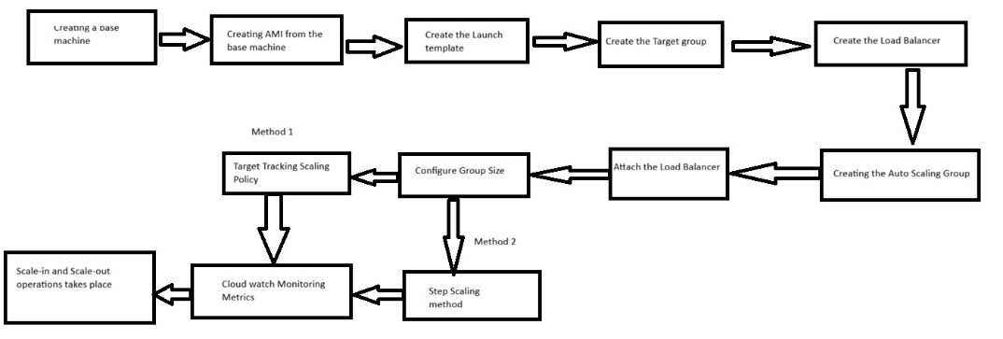
1.Create a base machine: arul-myweb
Name, AMI, type and key pairs are chosen.
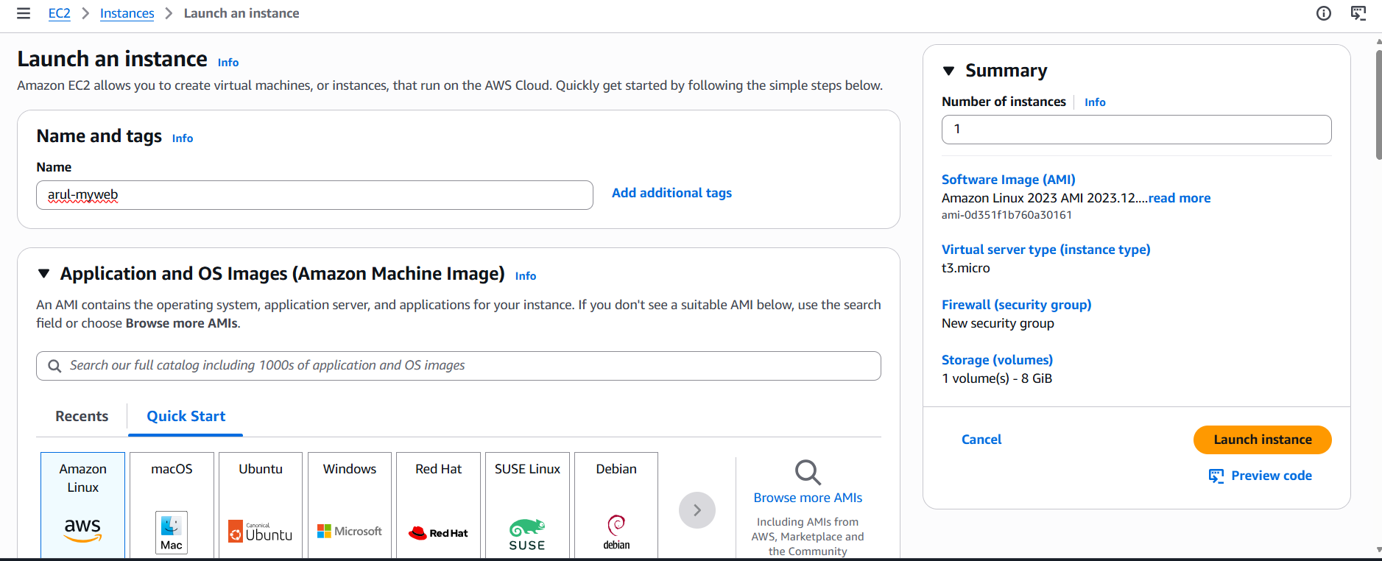
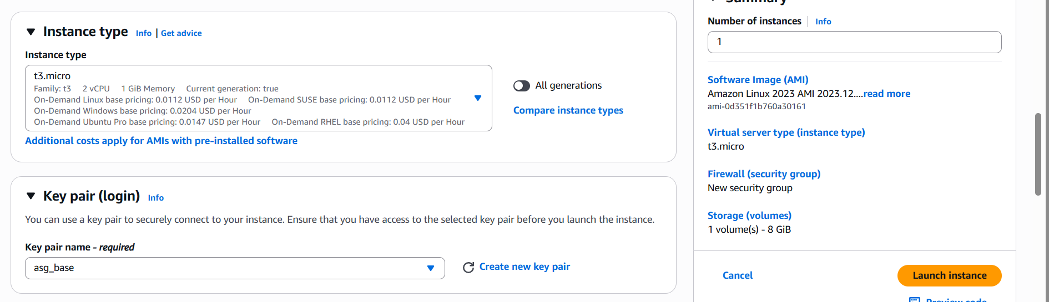
Port 80: http is enabled and SG is added:
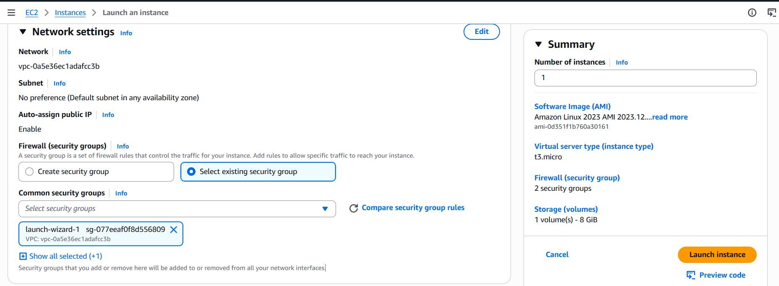
Installing the package via user data:
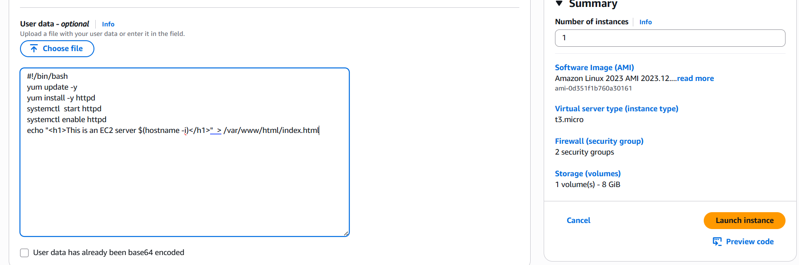
Machine created:
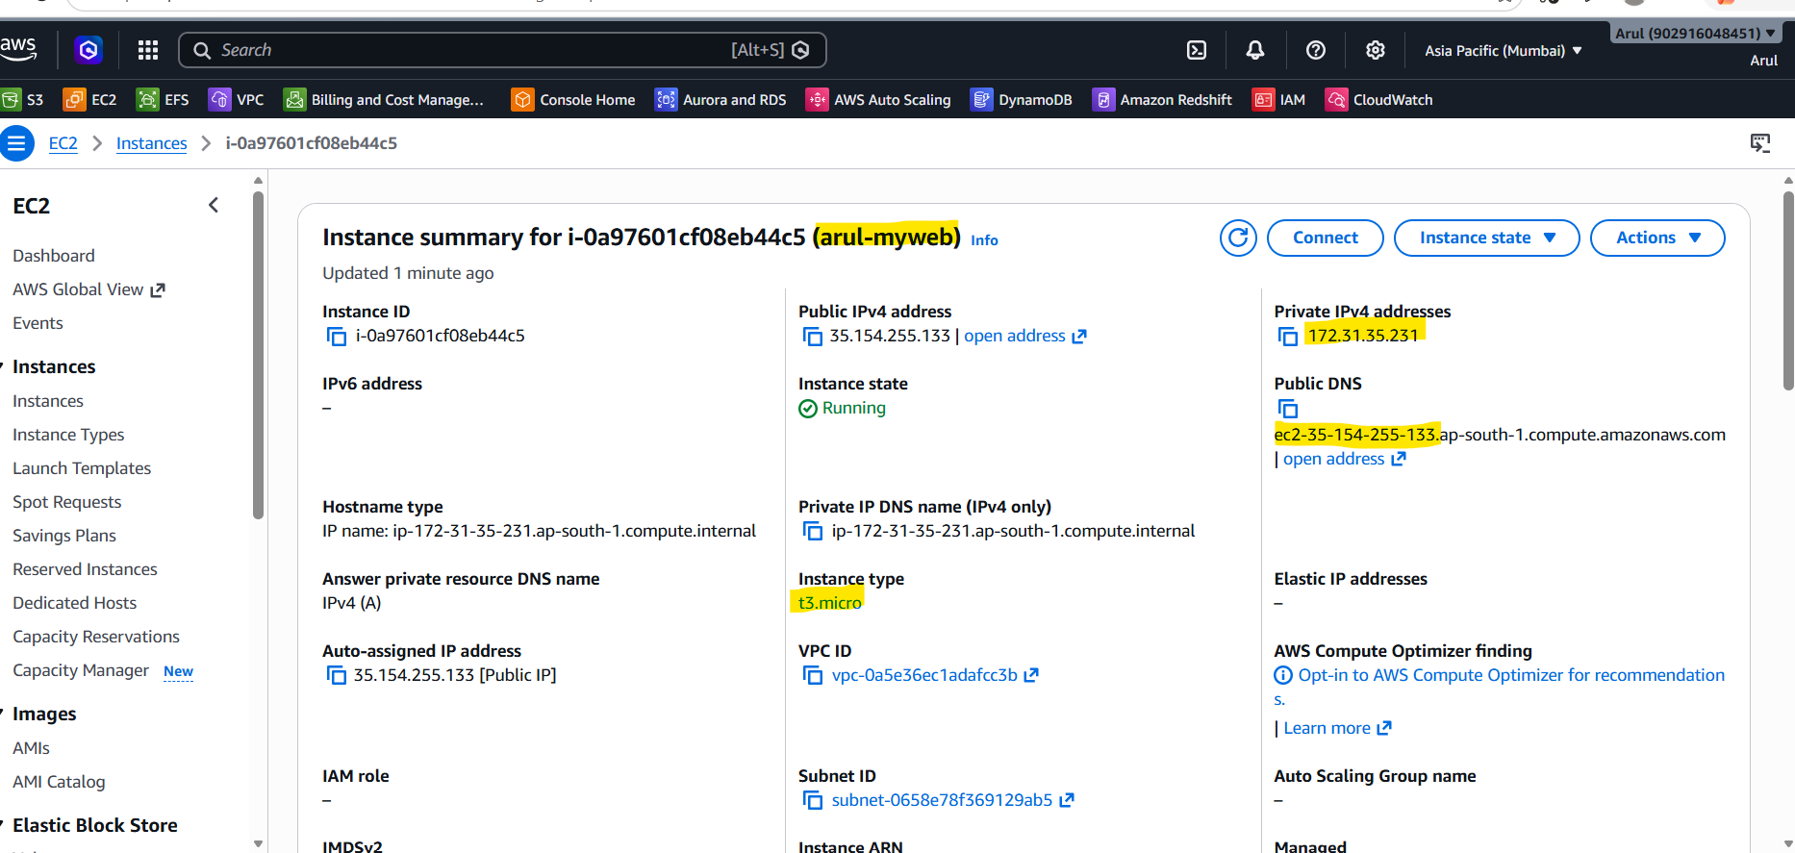
Web application is accessible over the browser:

Same has been verified at remote session:
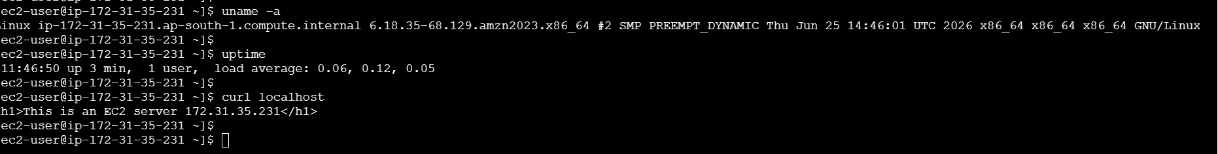
2.Creating AMI from the base machine
Select the machine Action Image & templates Create template from instance
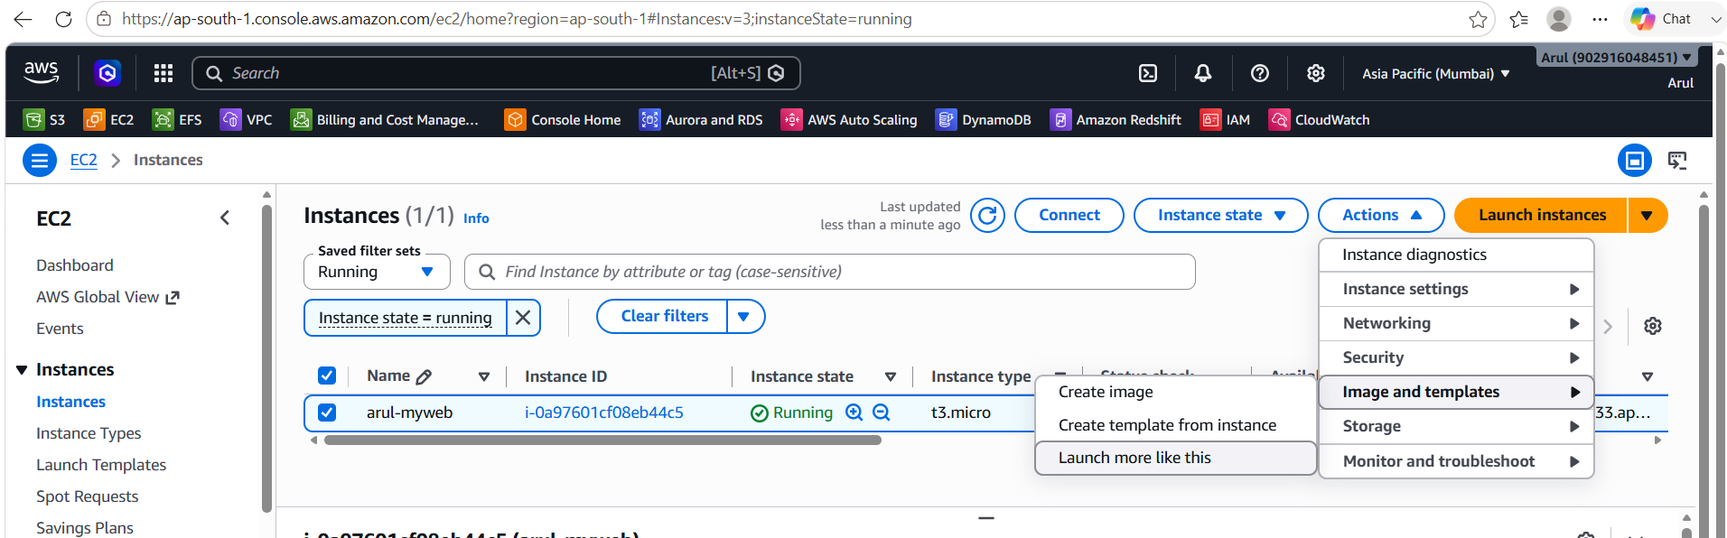
AMI name: arul-myweb-images
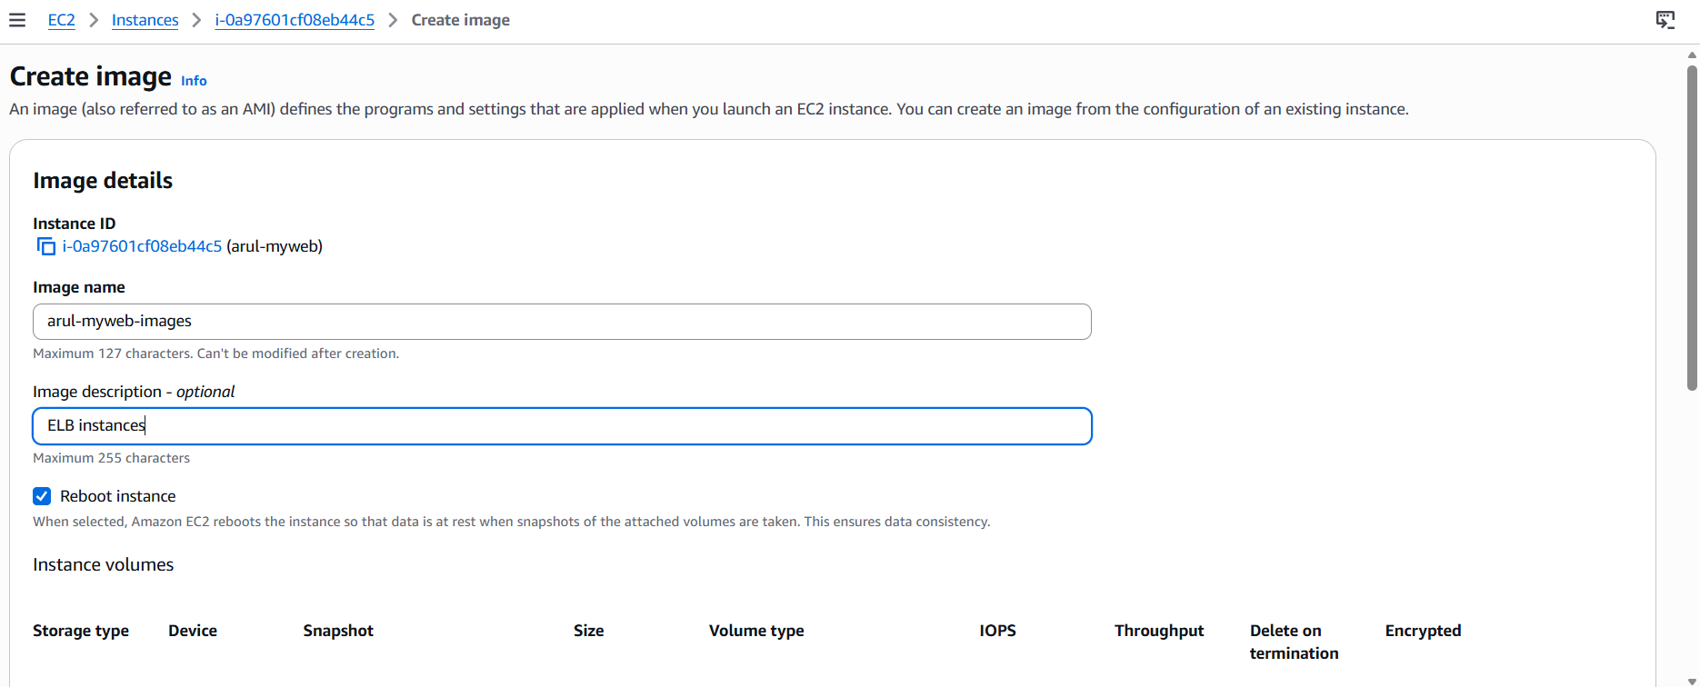
Image created: ami-07b78fea2e3f8d4bd
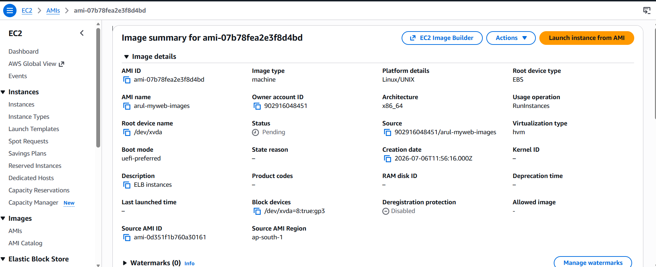
3.Create the Launch Template: arul-webservertemplate
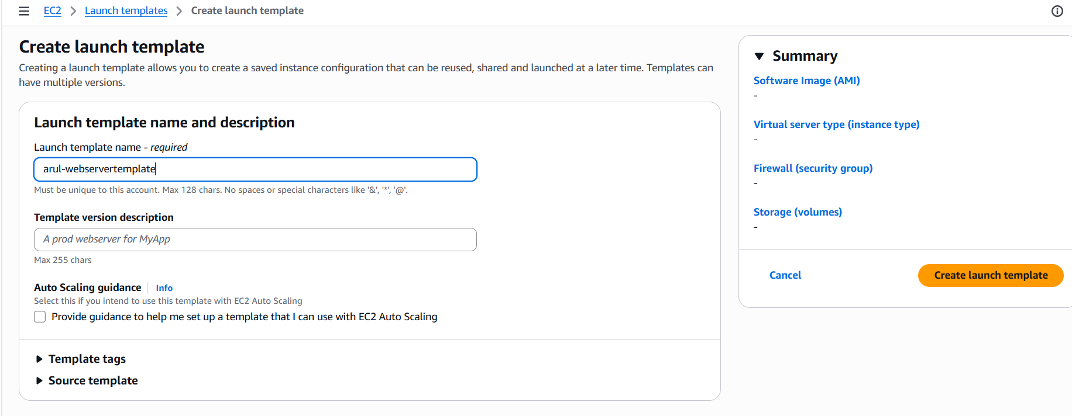
Choose the AMI: ami-07b78fea2e3f8d4bd
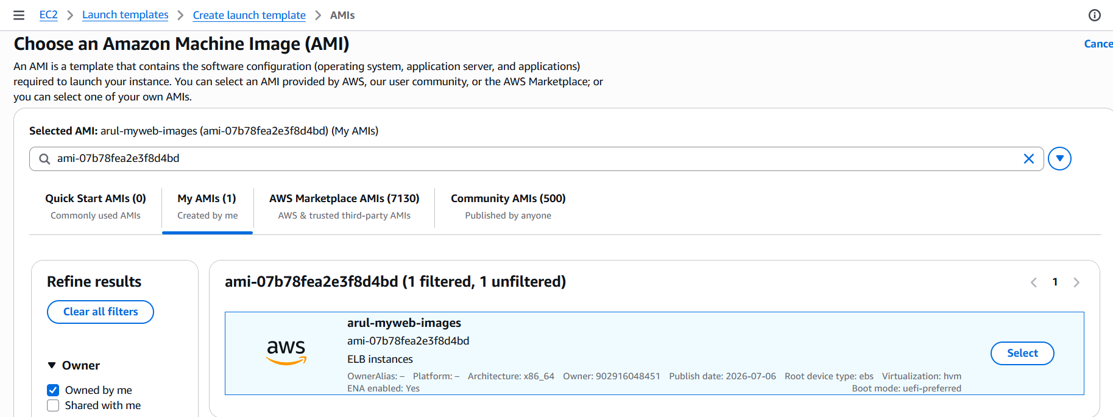
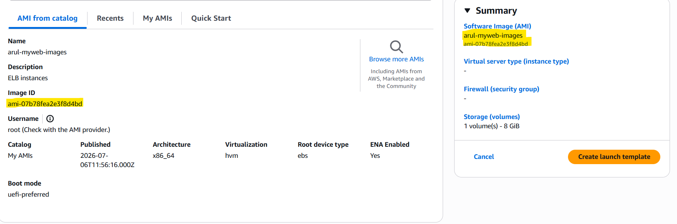
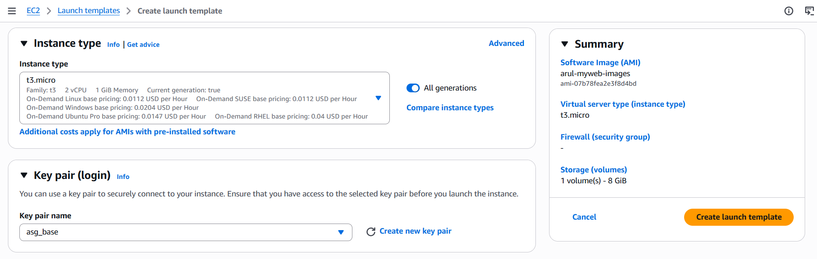
Select the SG & 3 AZ:
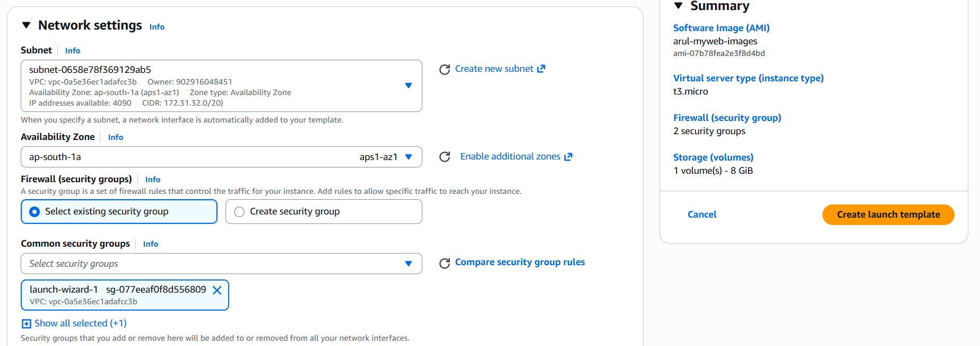
Launch template created.
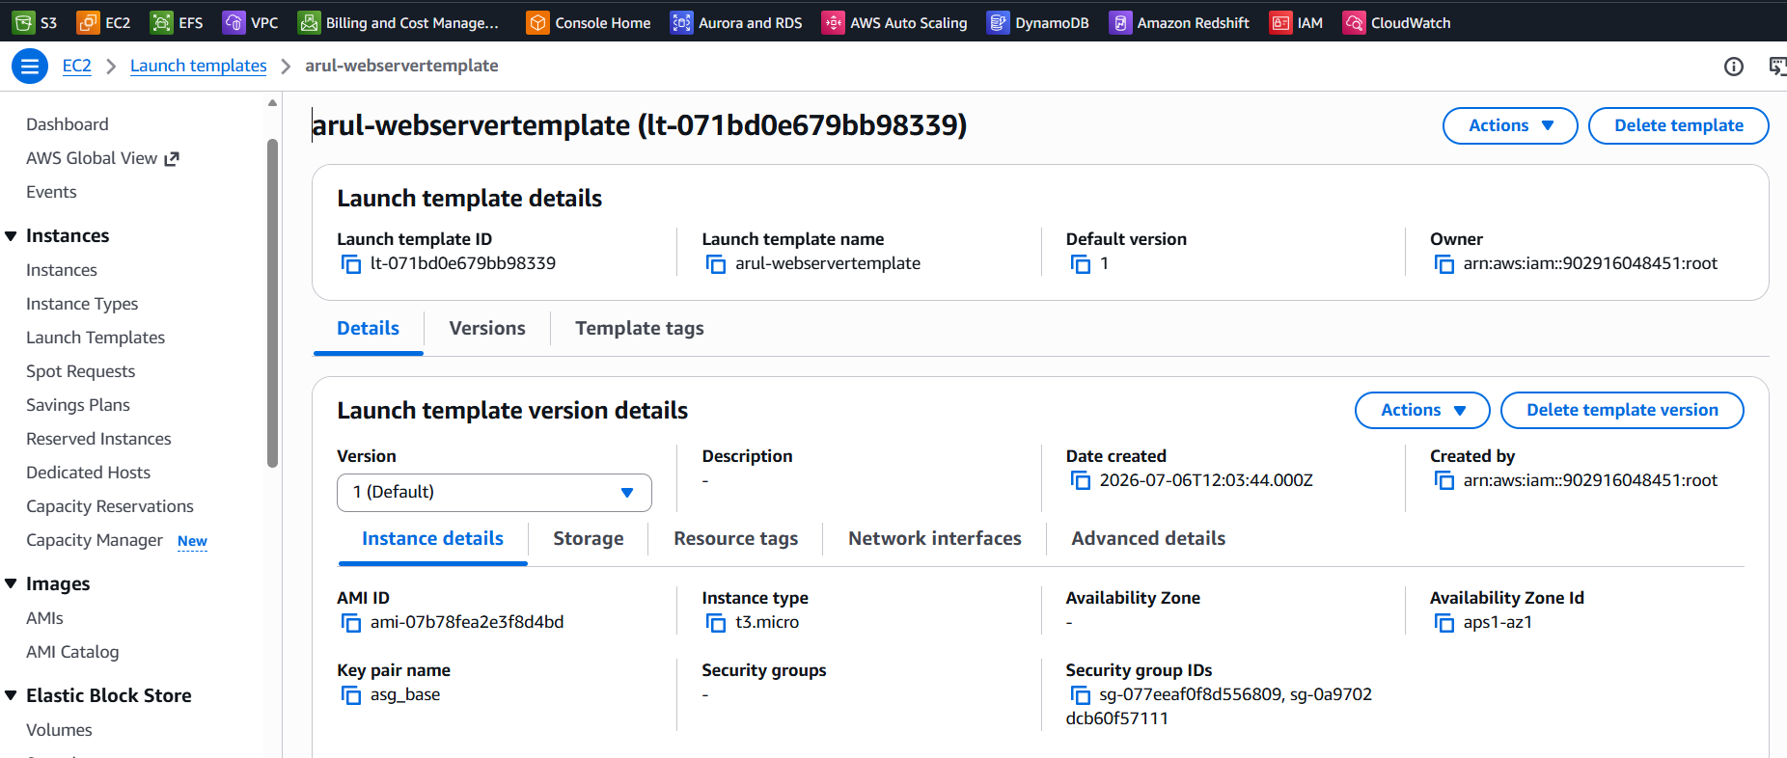
4.Create the Instance Target Group: arul-webtarget
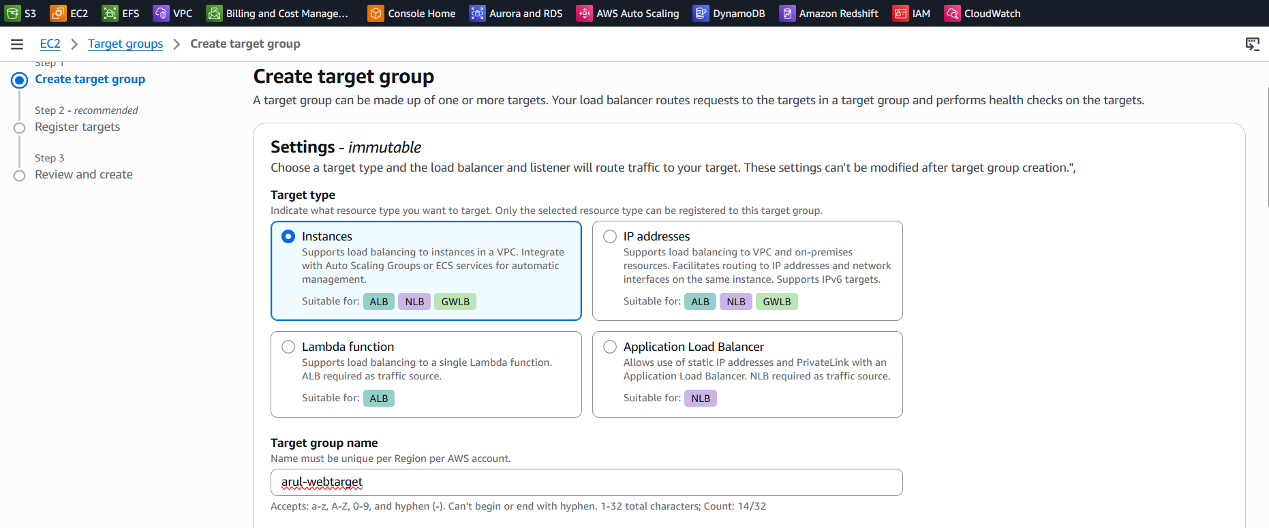
Mention Protocol (http:80) and IP type, Health Check:
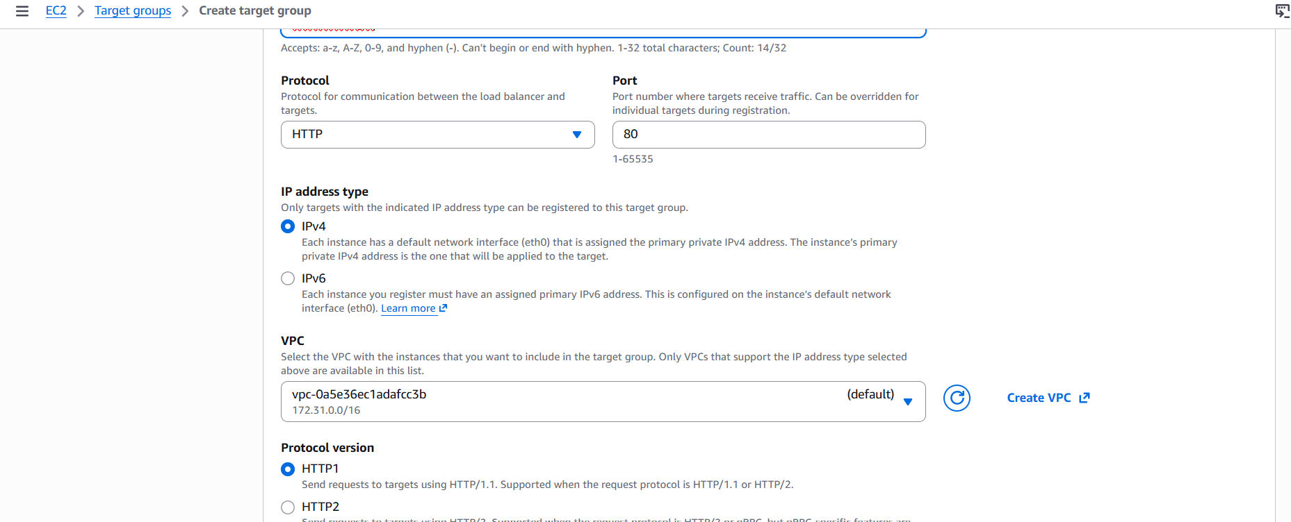
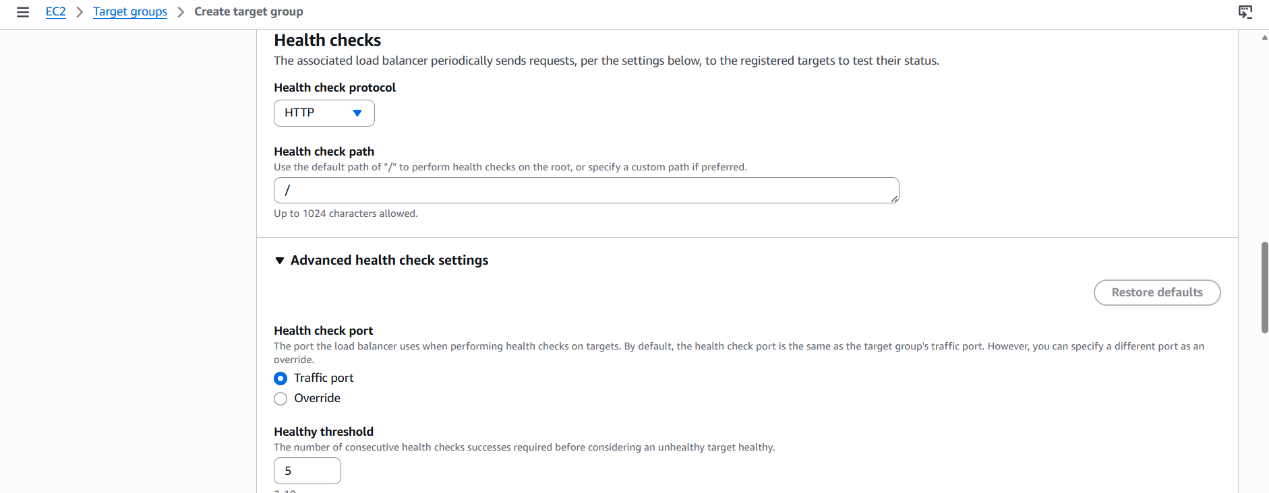
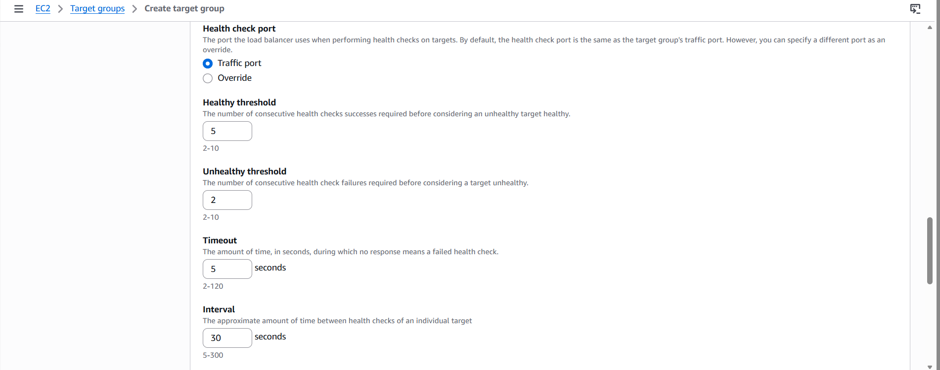
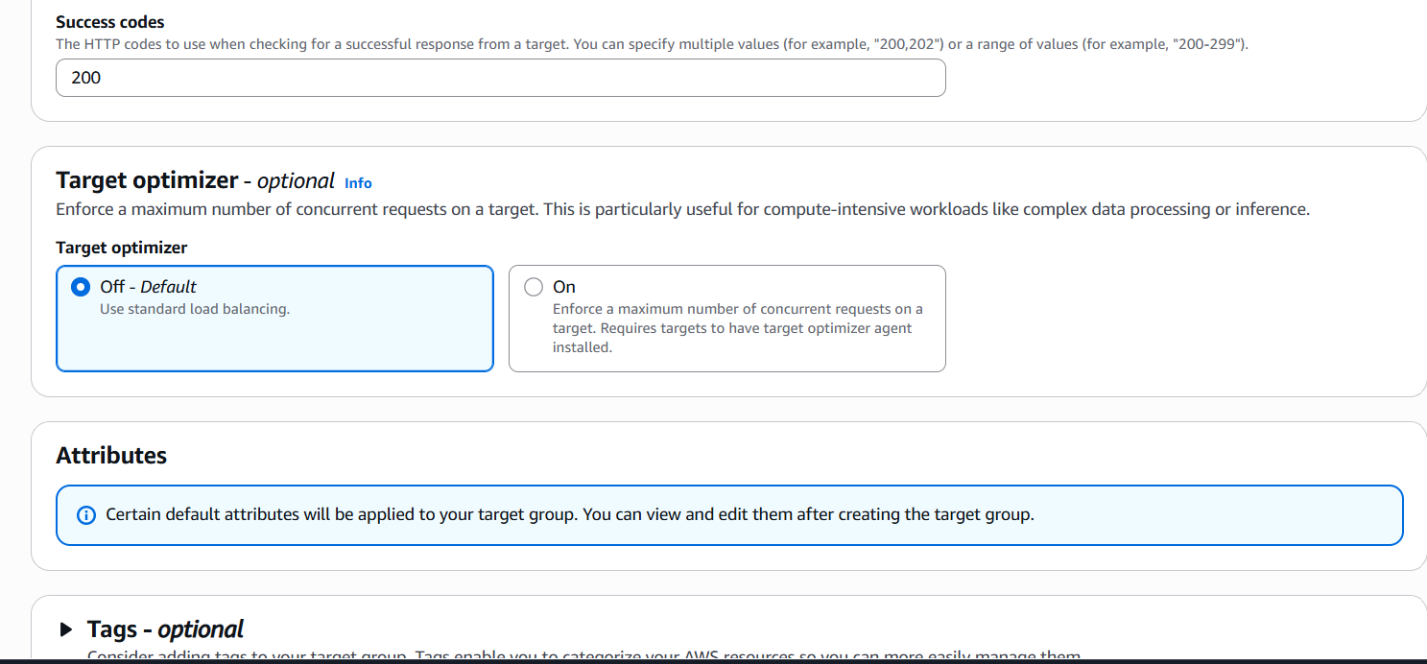
Target group created:
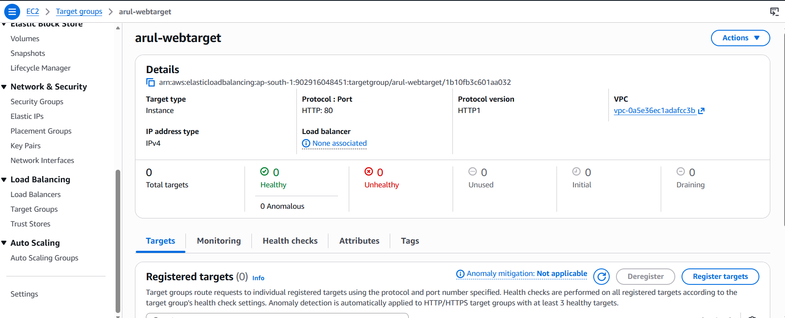
5.Create Application Load Balancer: arul-webalb
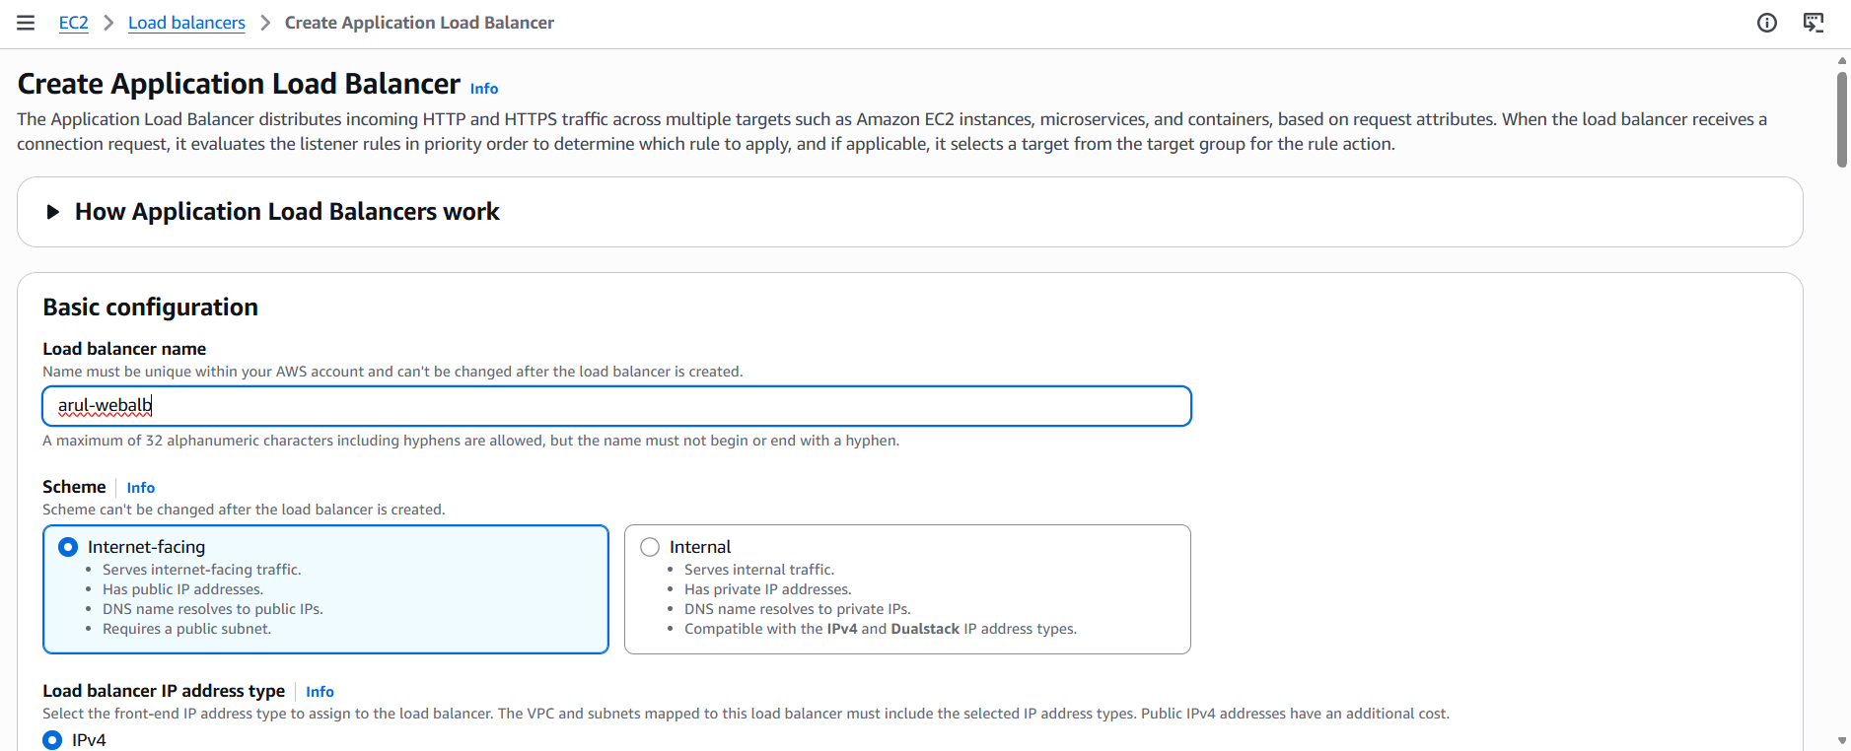
Mention VPC, AZ, Security groups:
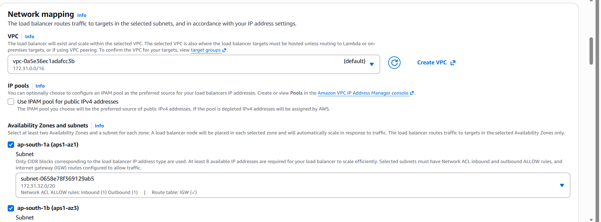
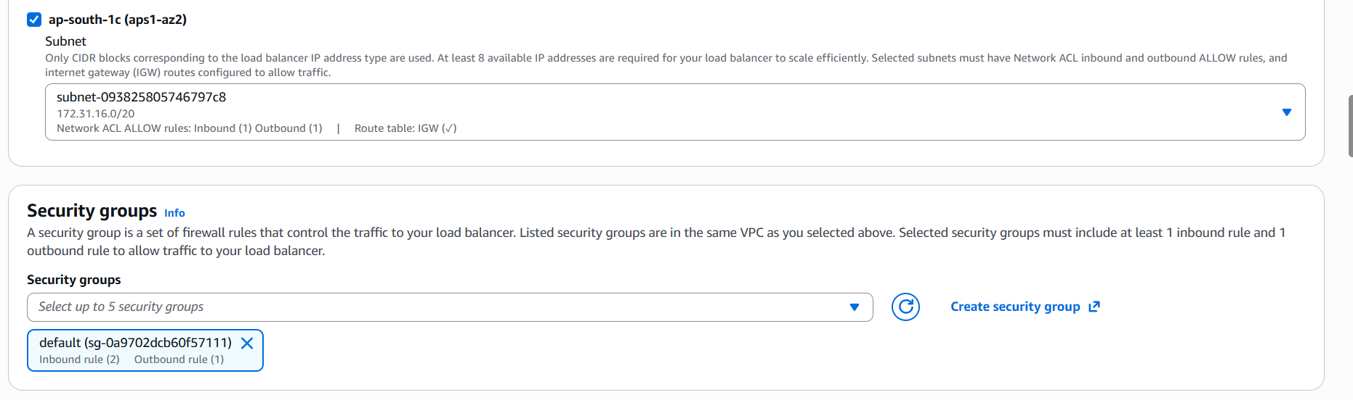
Add the Listener and Target group:
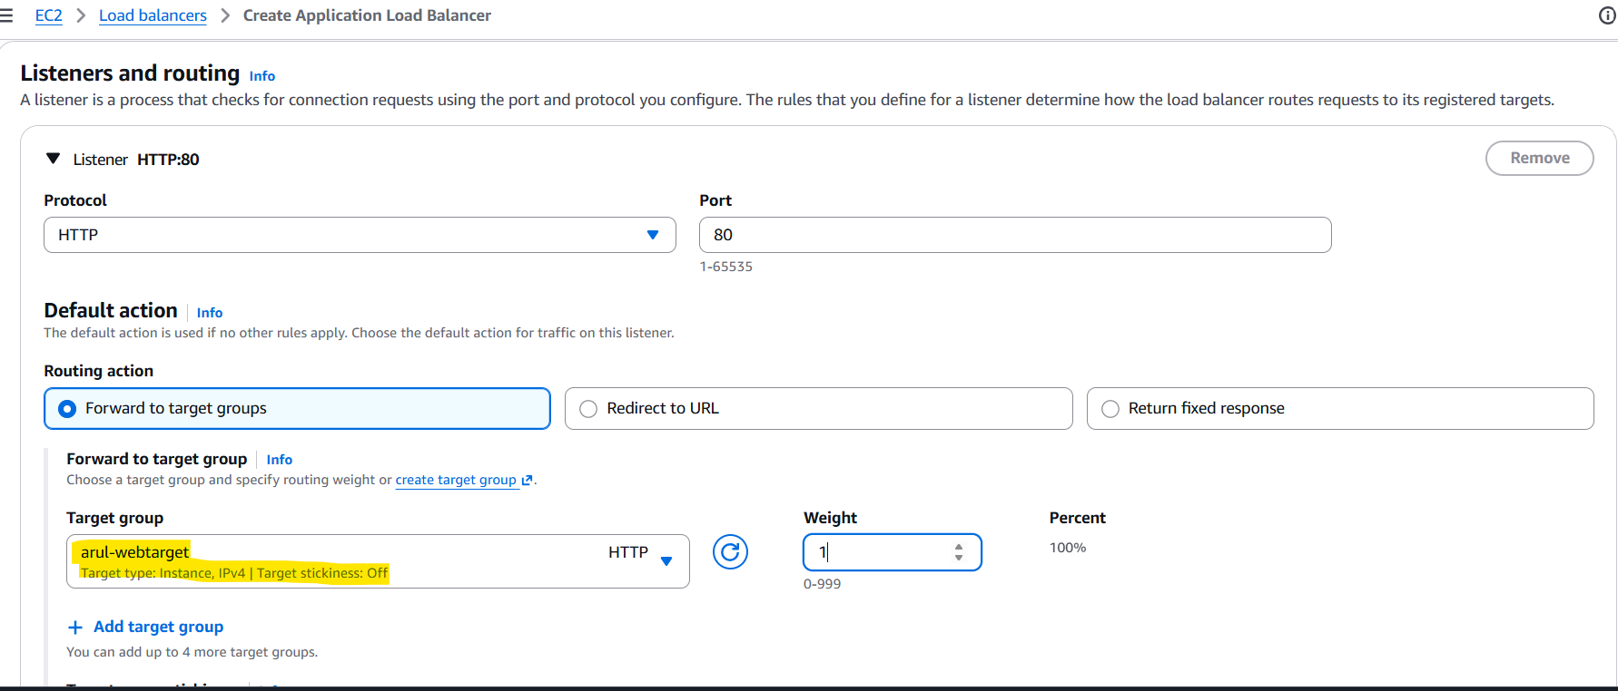
Load Balancer created with DNS: arul-webalb-644963968.ap-south-1.elb.amazonaws.com
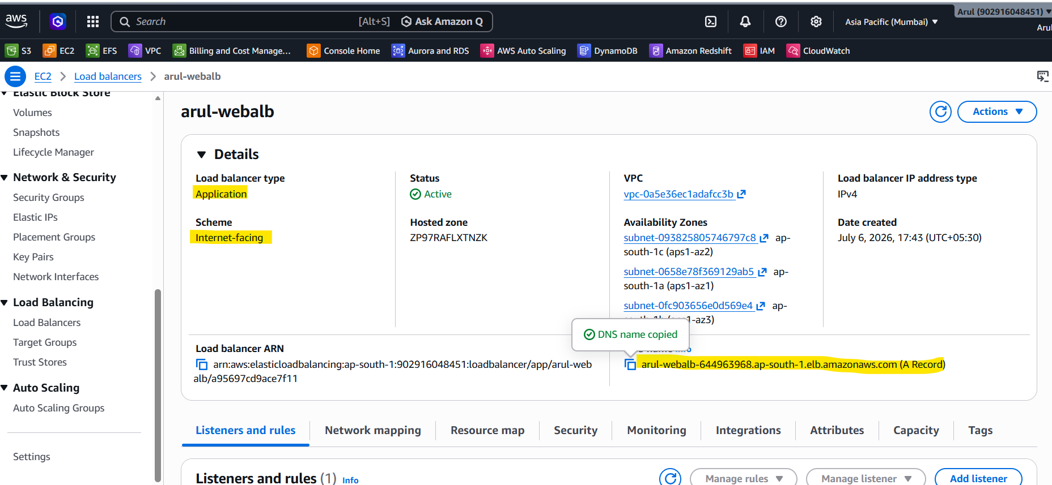
6.Create Auto Scaling Group: arul-mywebasg
Mention the Launch template: arul-webservertemplate
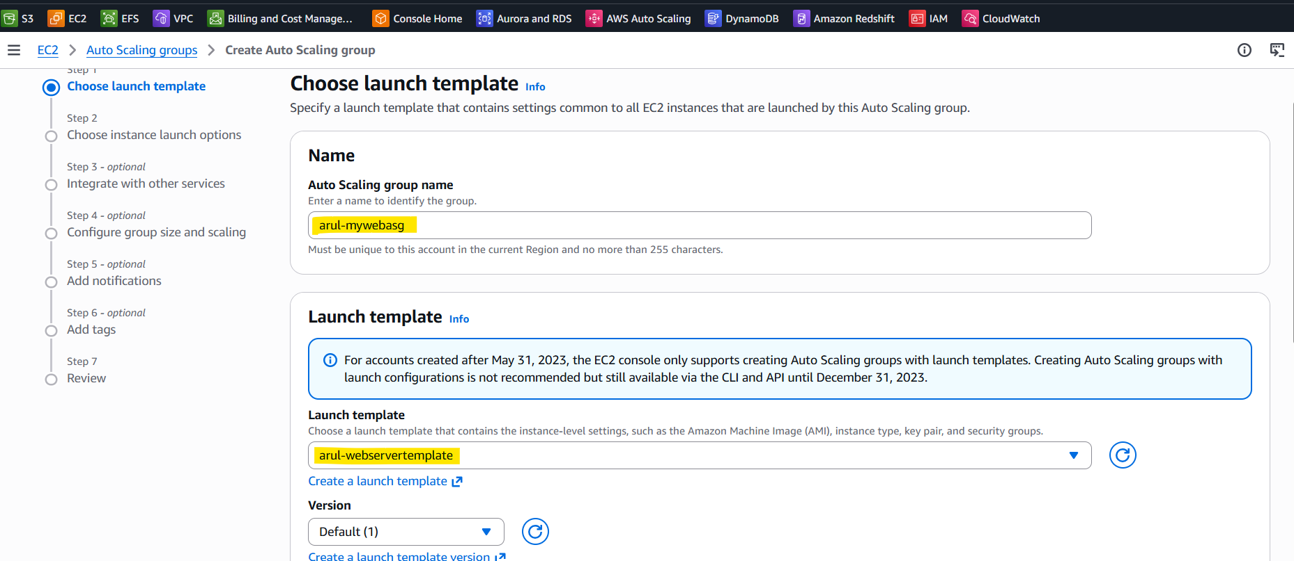
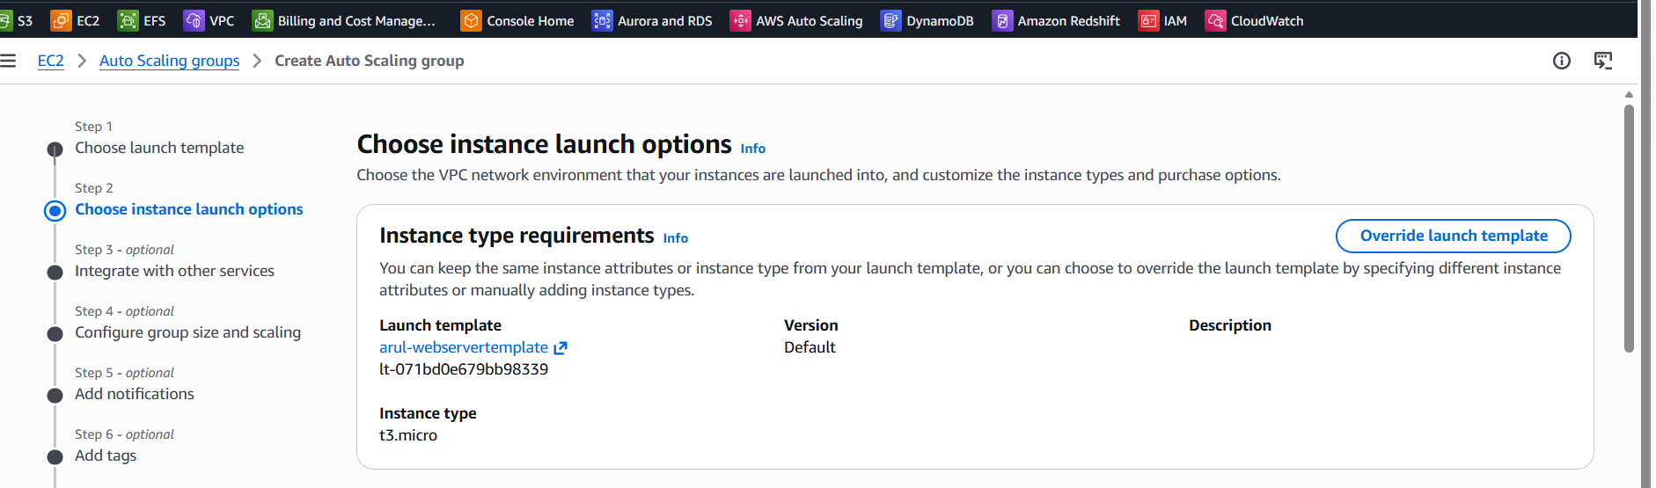
Mention the VPC, AZ and AZ distribution:
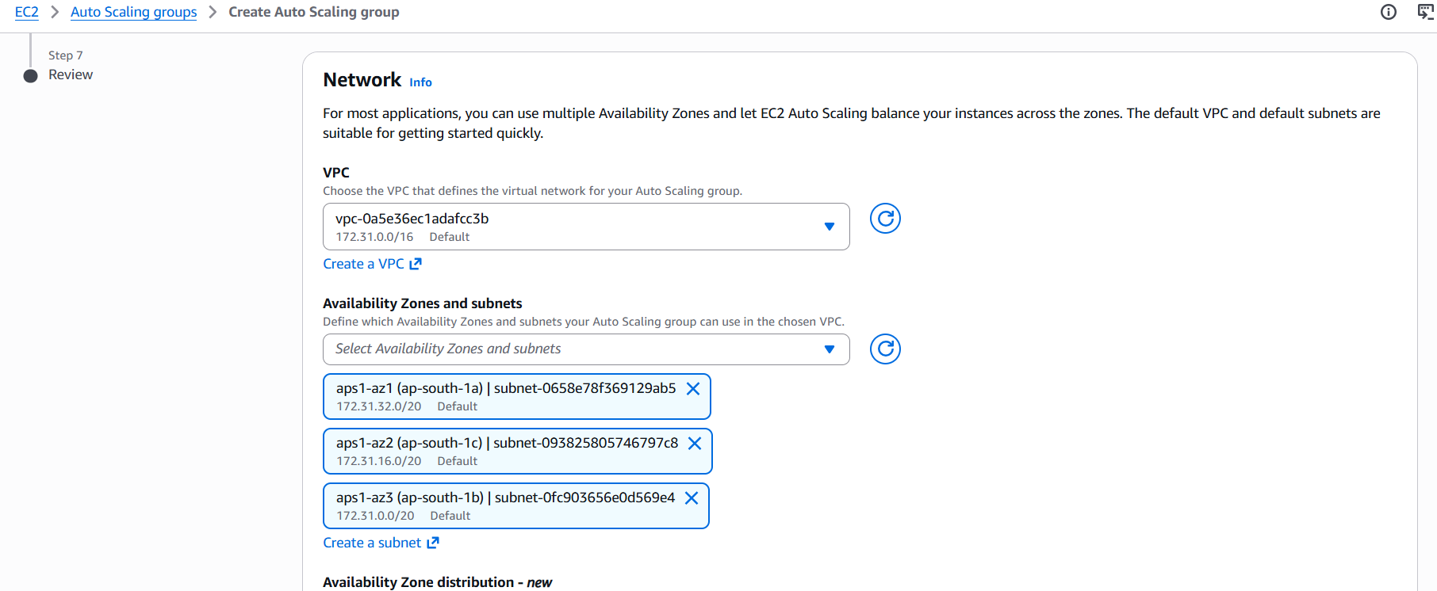
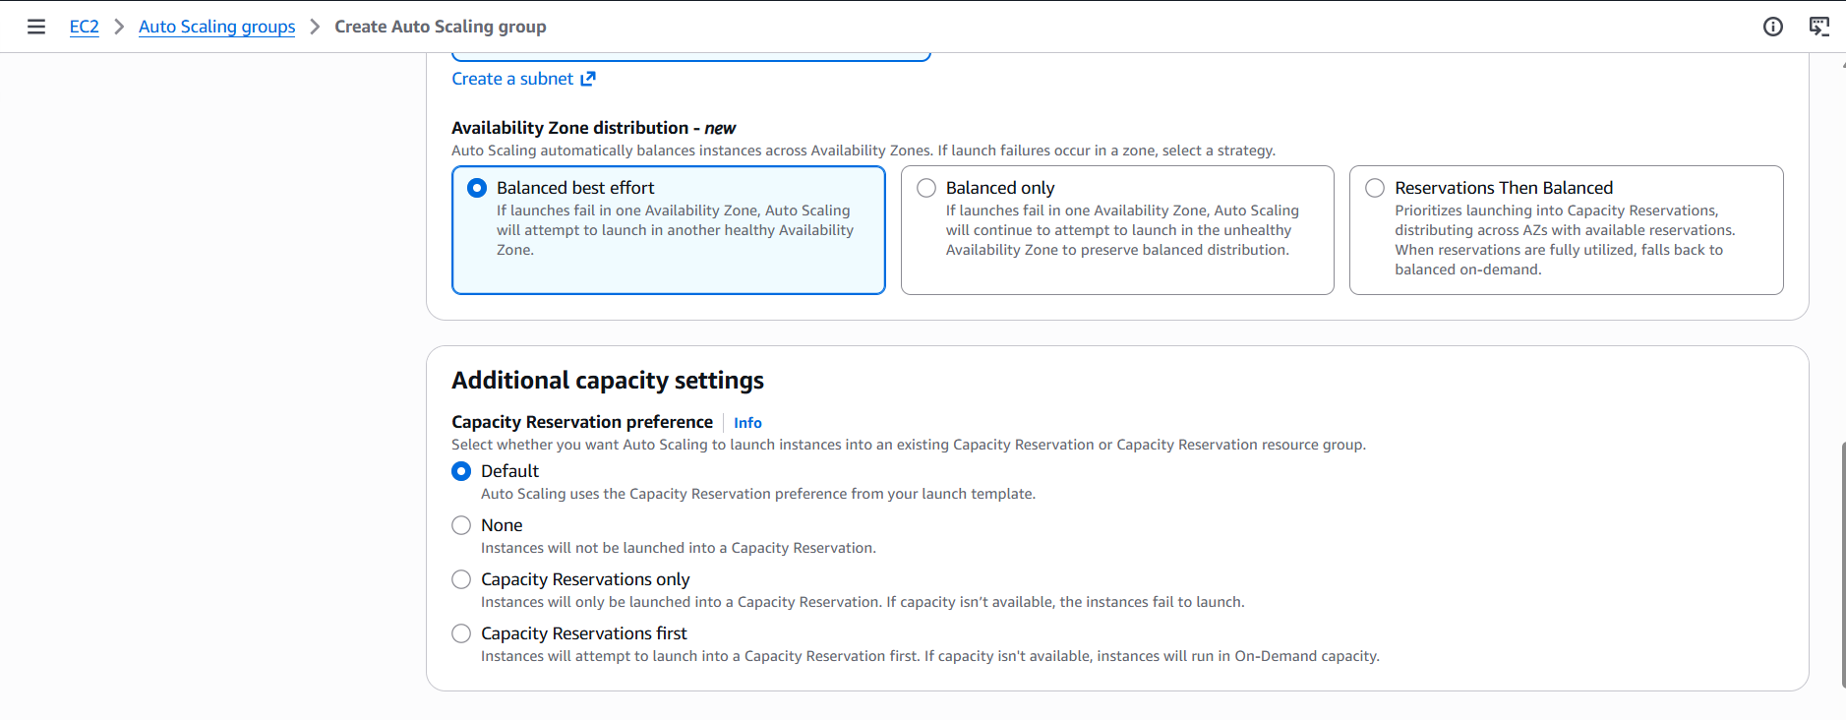
7.Attach the Load balancer:arul-webalb
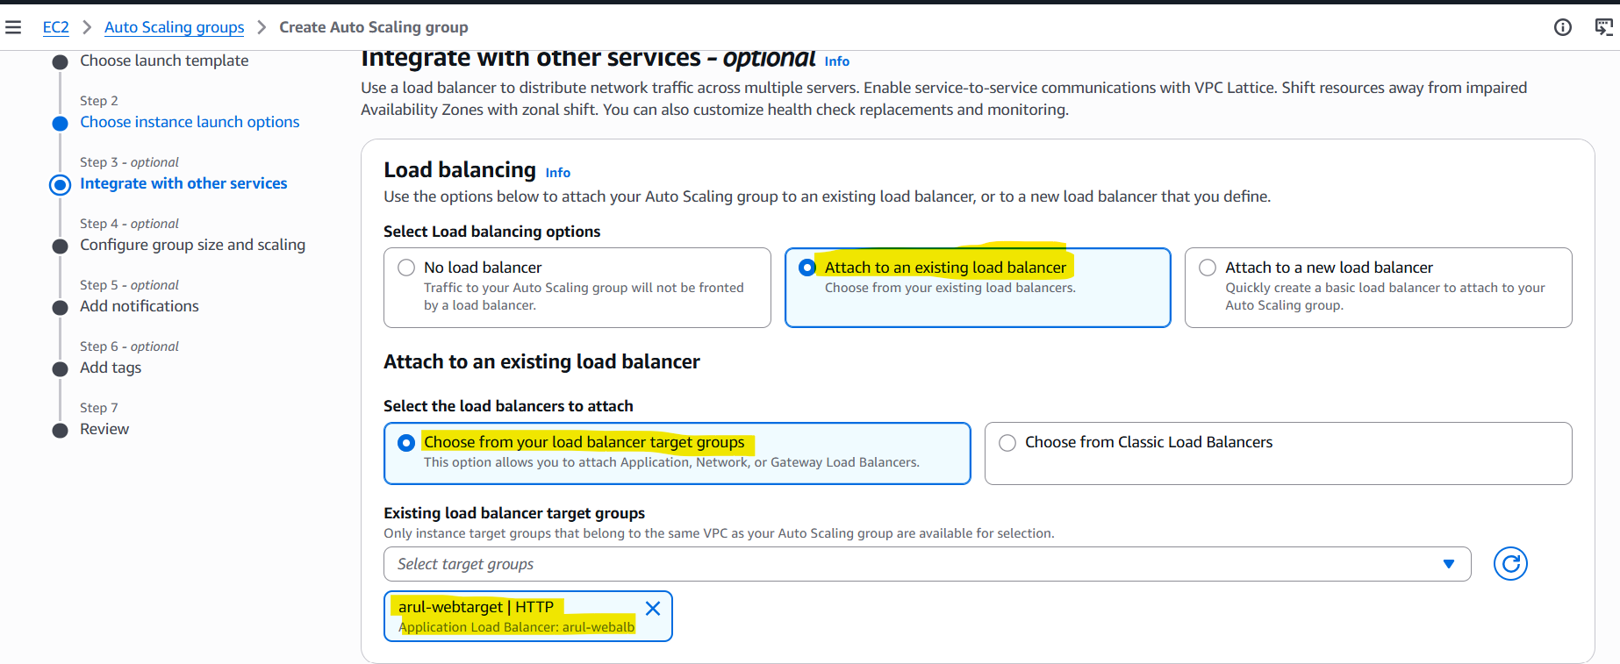
Specify the health check parameters:
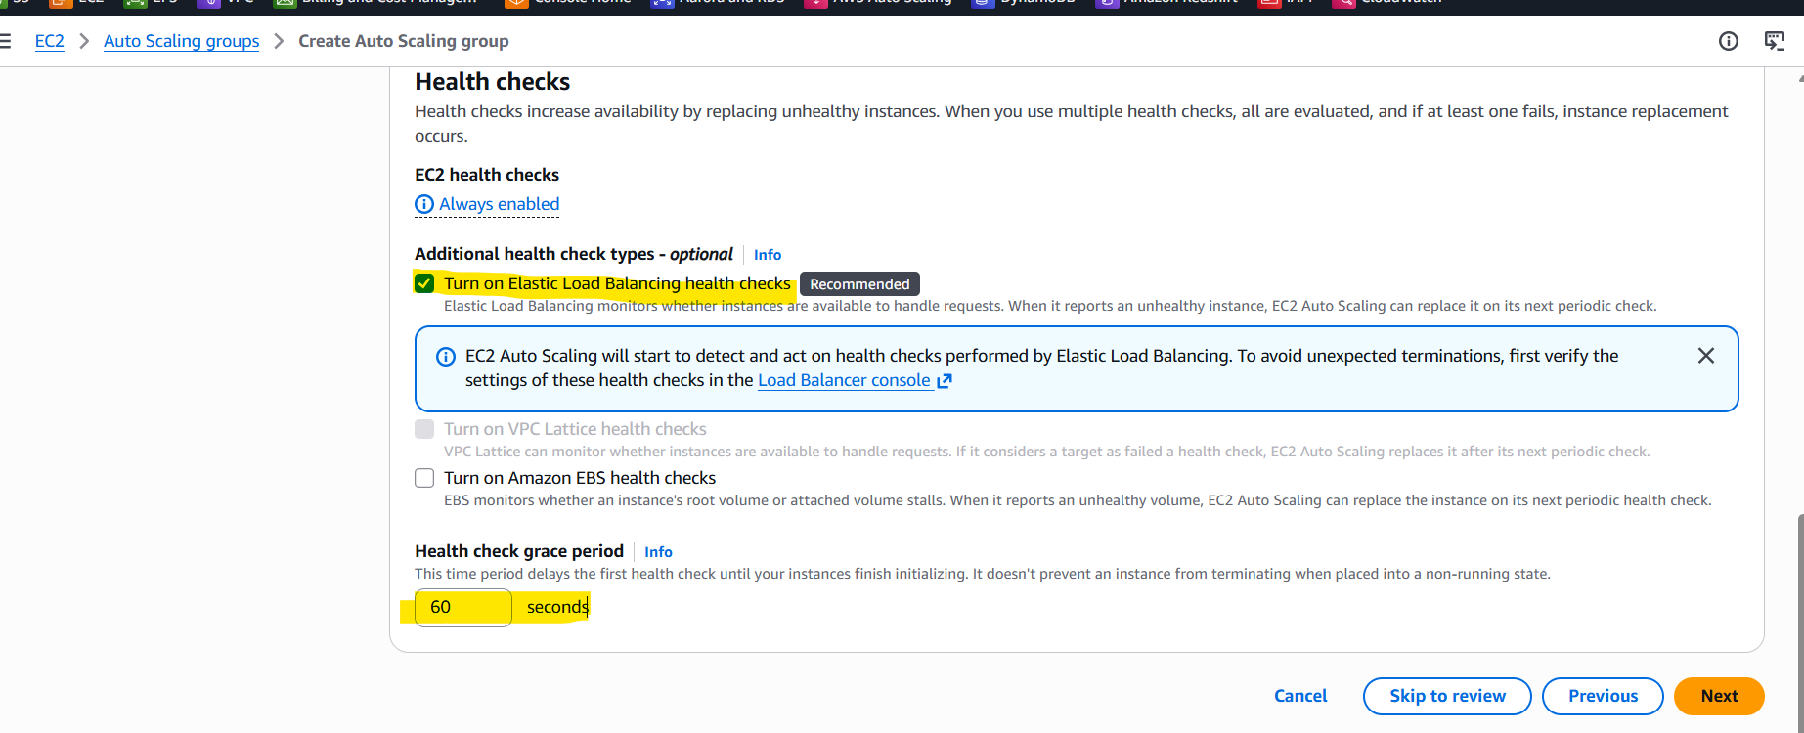
8.Configure Group Size: Desired: 2, Min:2 and Max:5
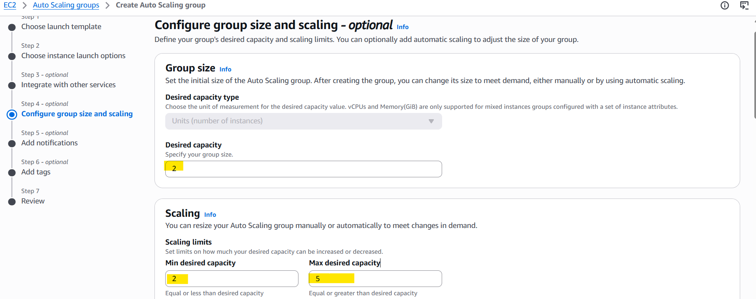
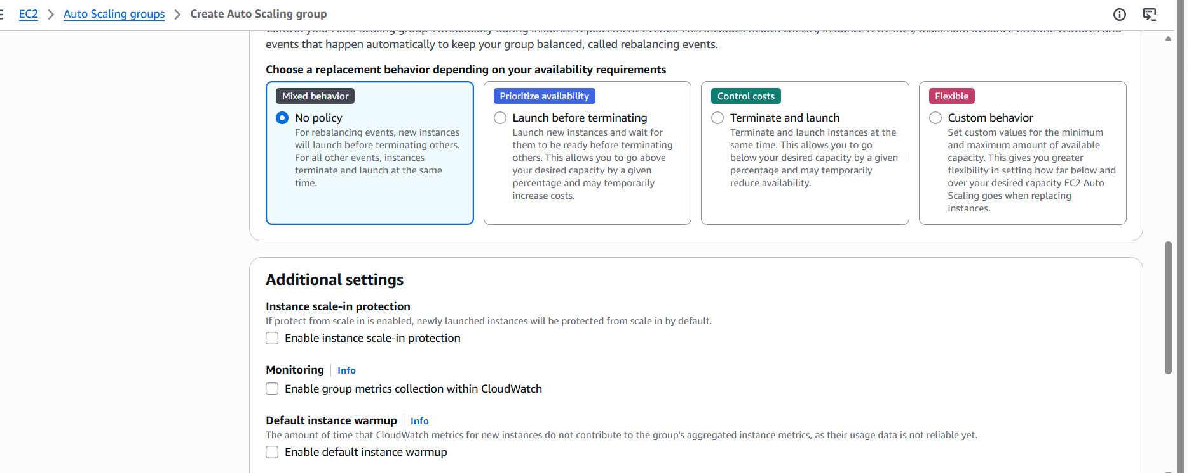
Auto Scaling group created:
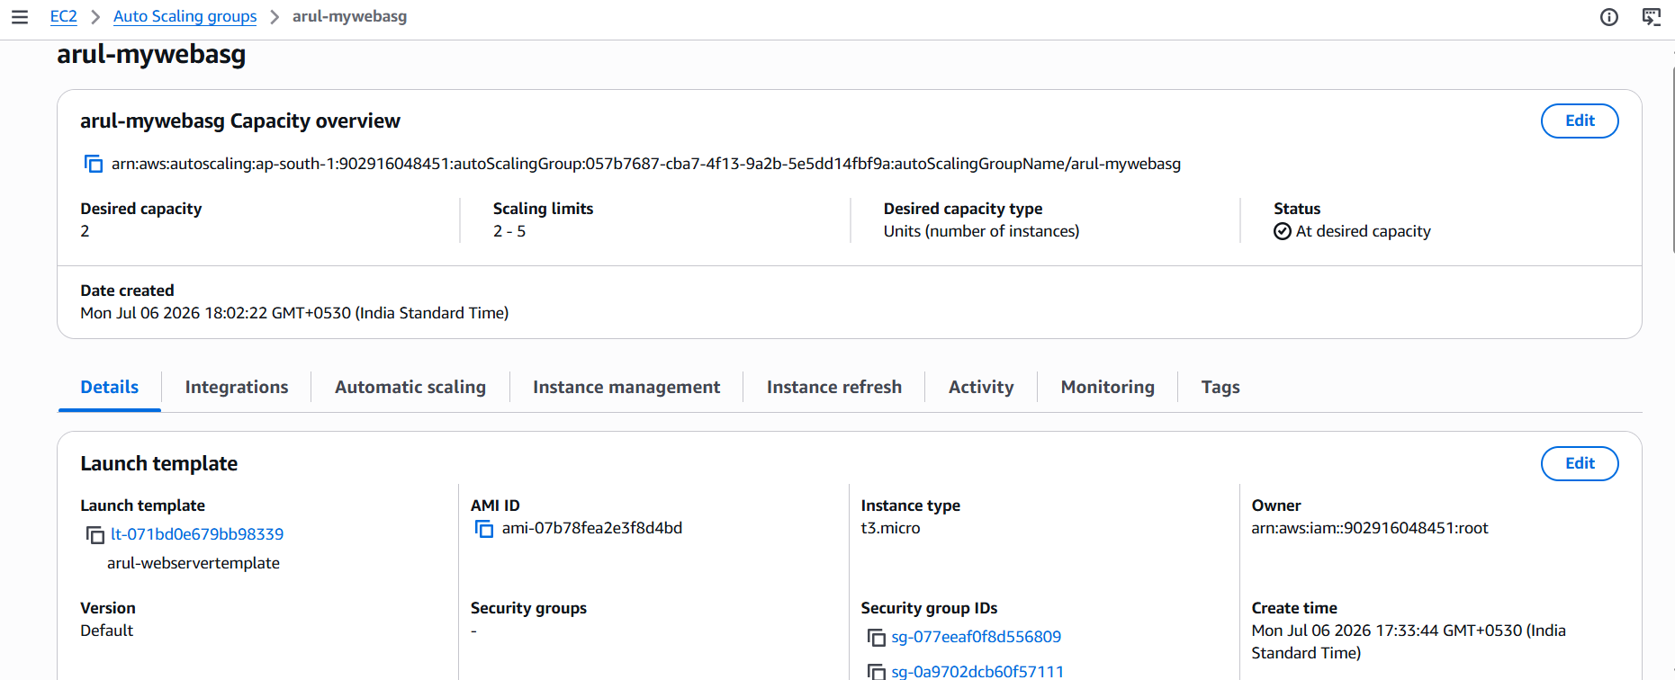
Method 1: Dynamic Scaling Policy
Specify the CPU usage:80% and warmup 150 sec.
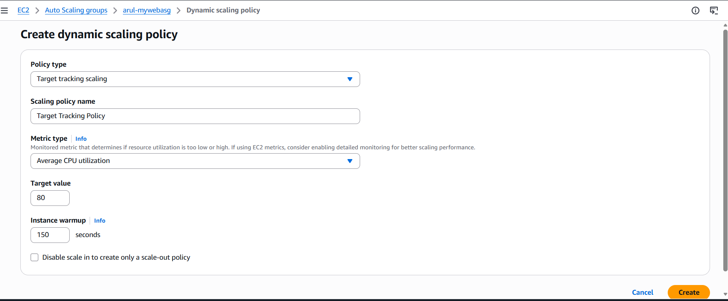

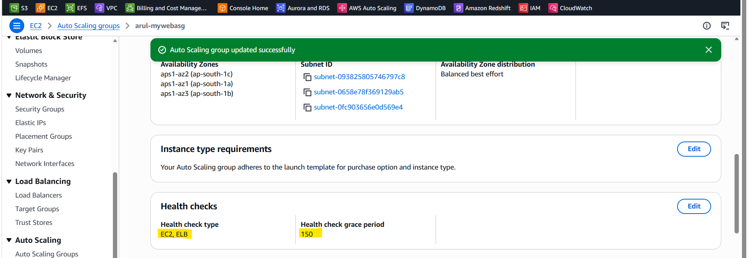
Two instances were created as per below activity log:
i-08bec3e1759296499 - 173.13.5.212
i-074ef236ada1e1ef9 – 173.13.20.240
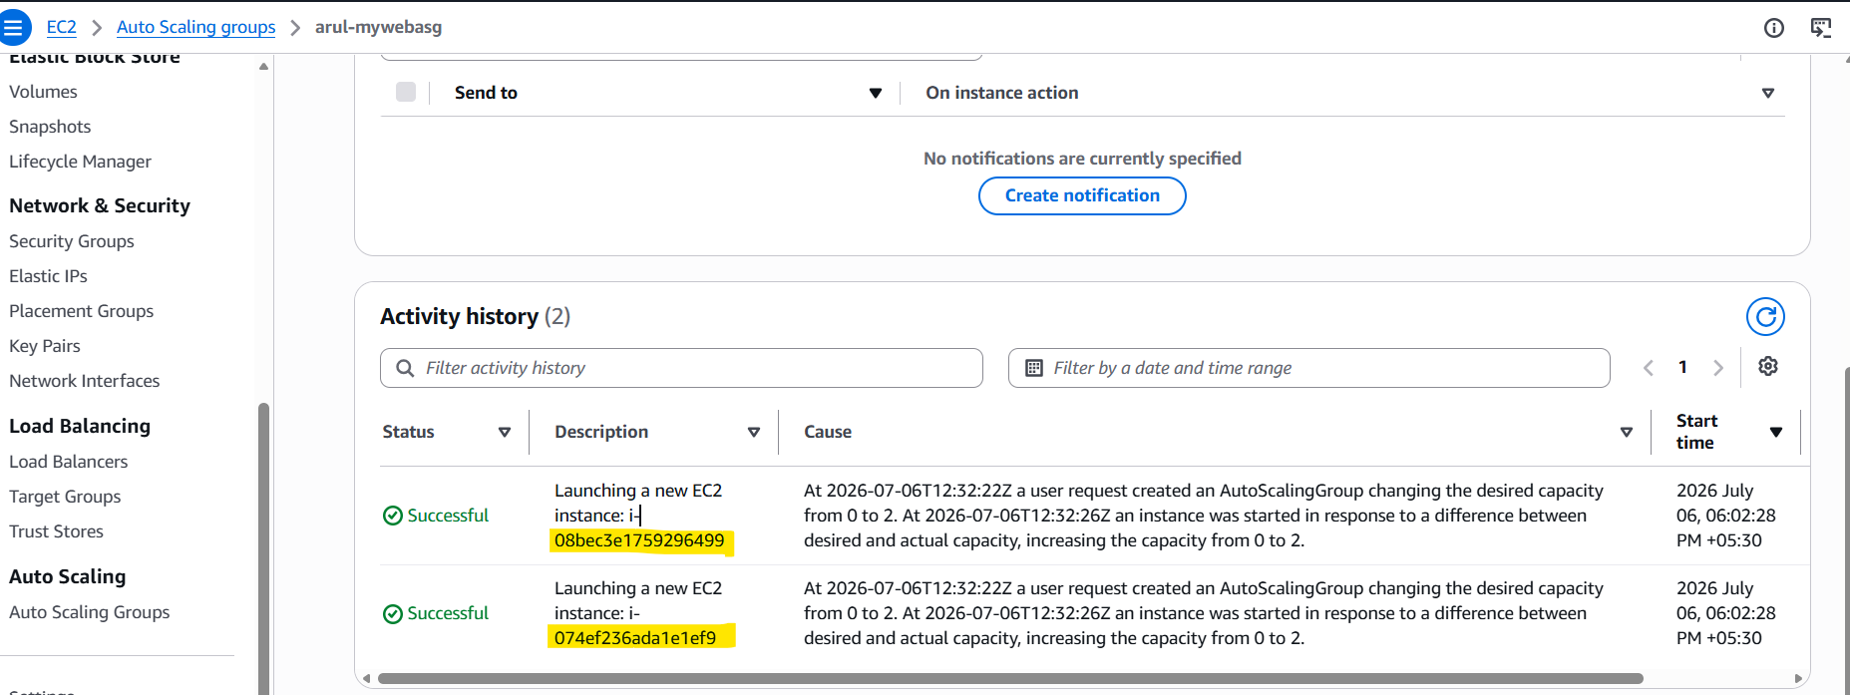
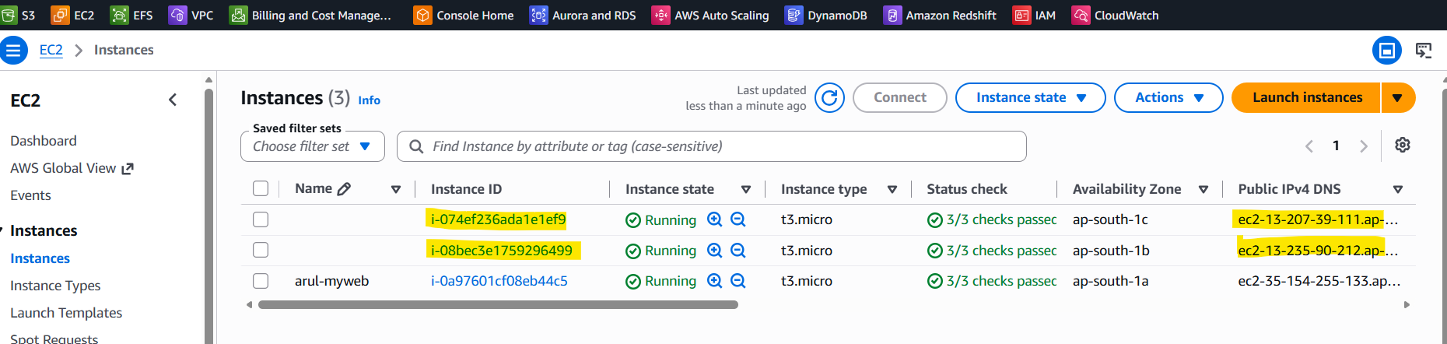
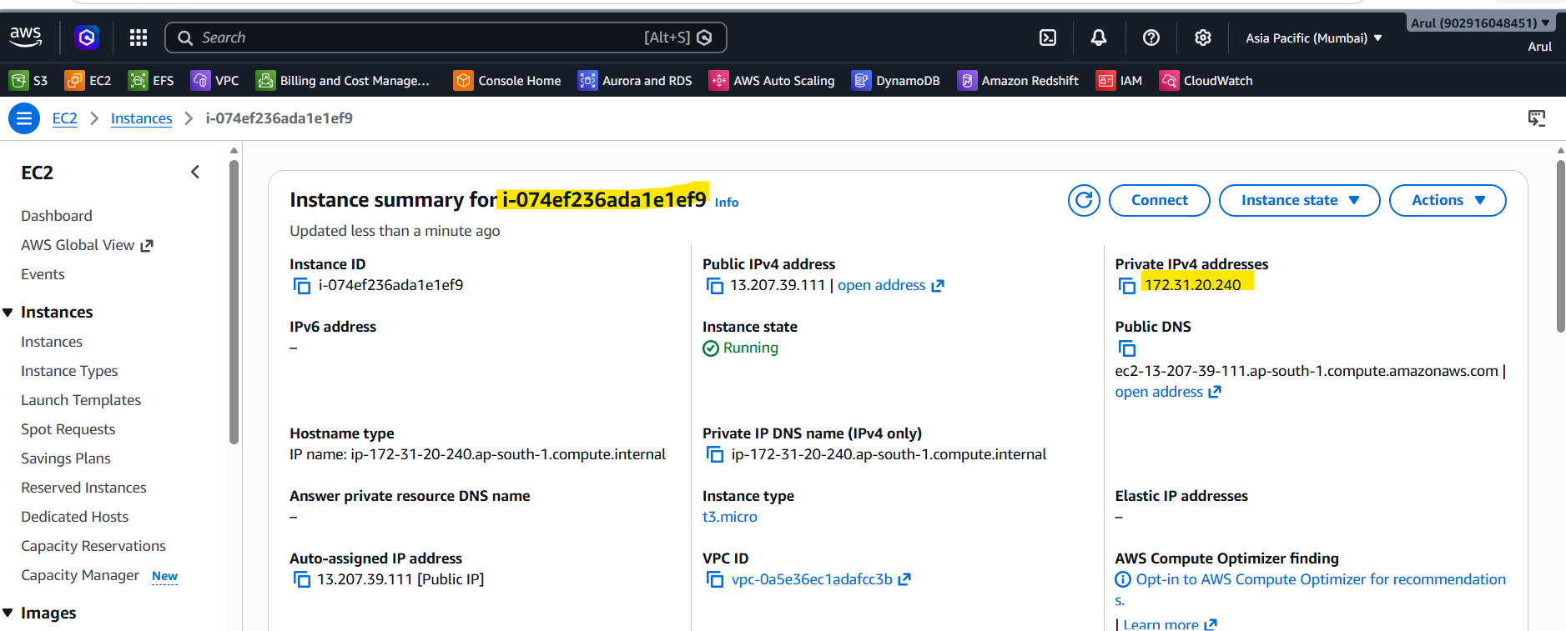
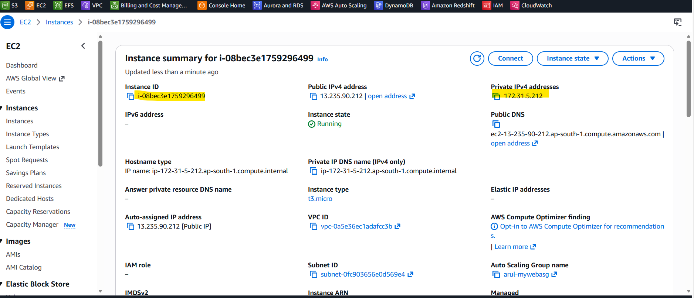
After enabling the port http -80, ALB is working over the browser:



Creating the Cloudwatch monitor and SNS notofication:
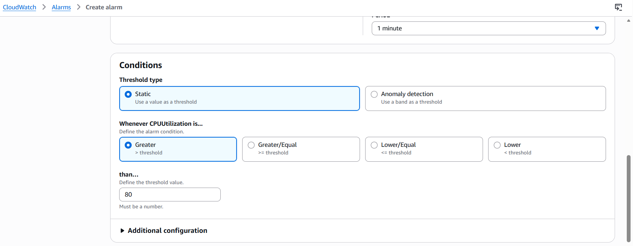
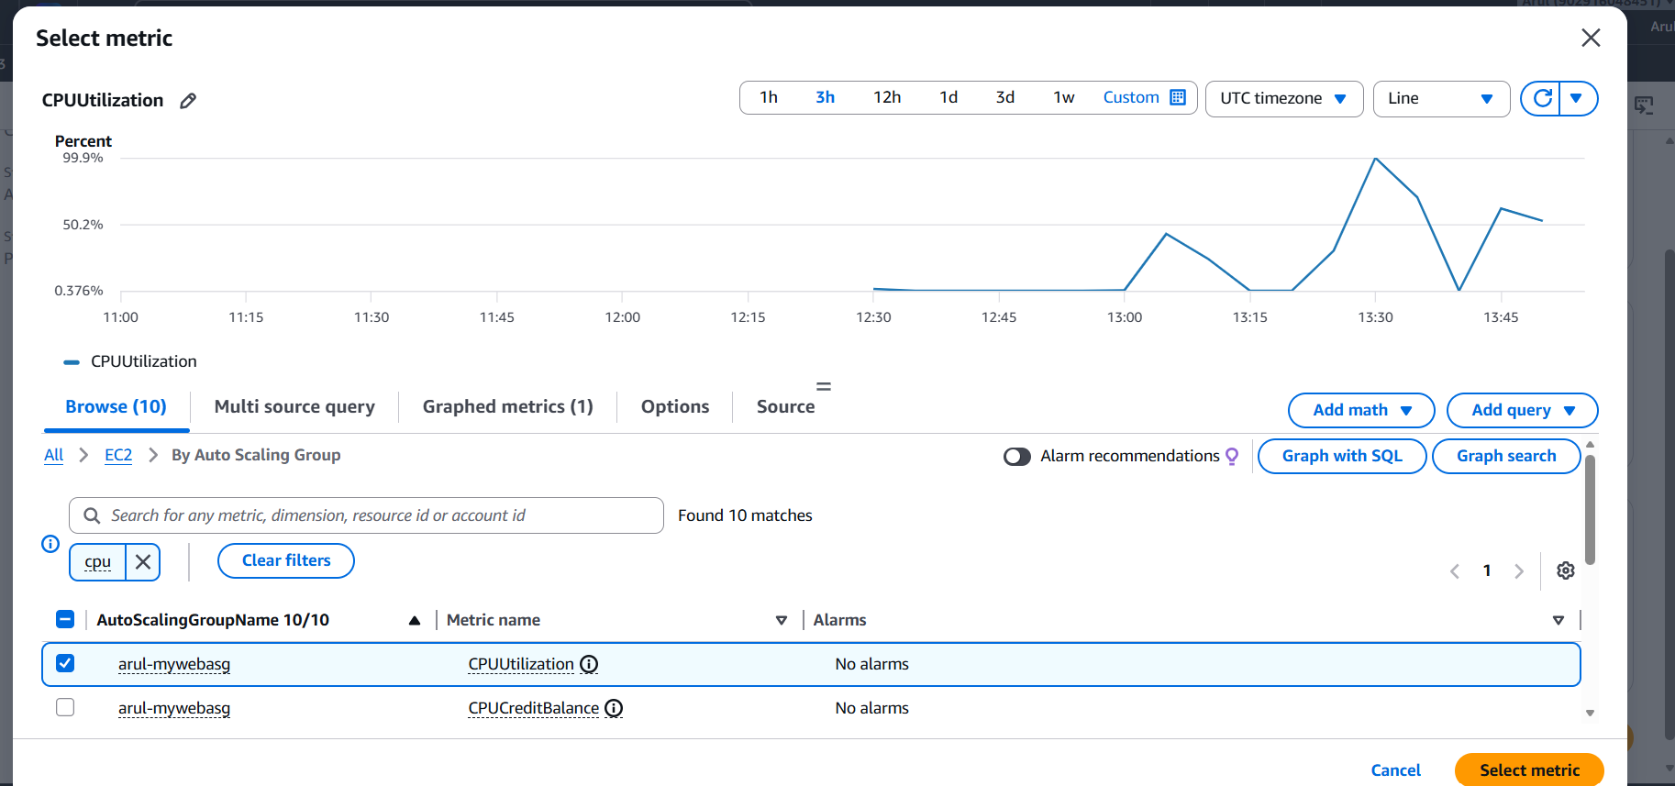
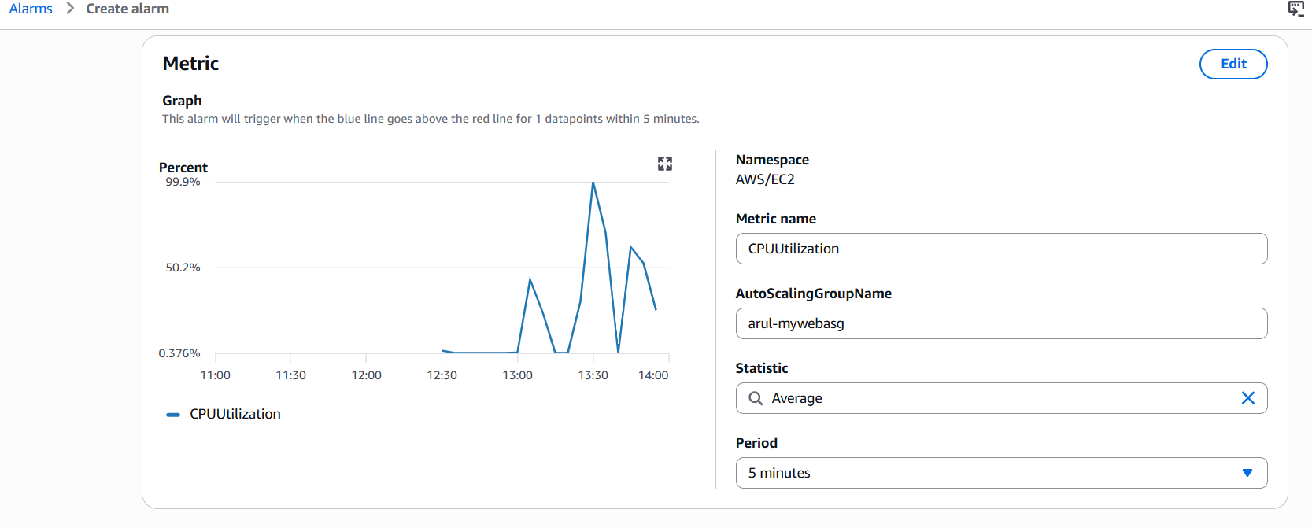
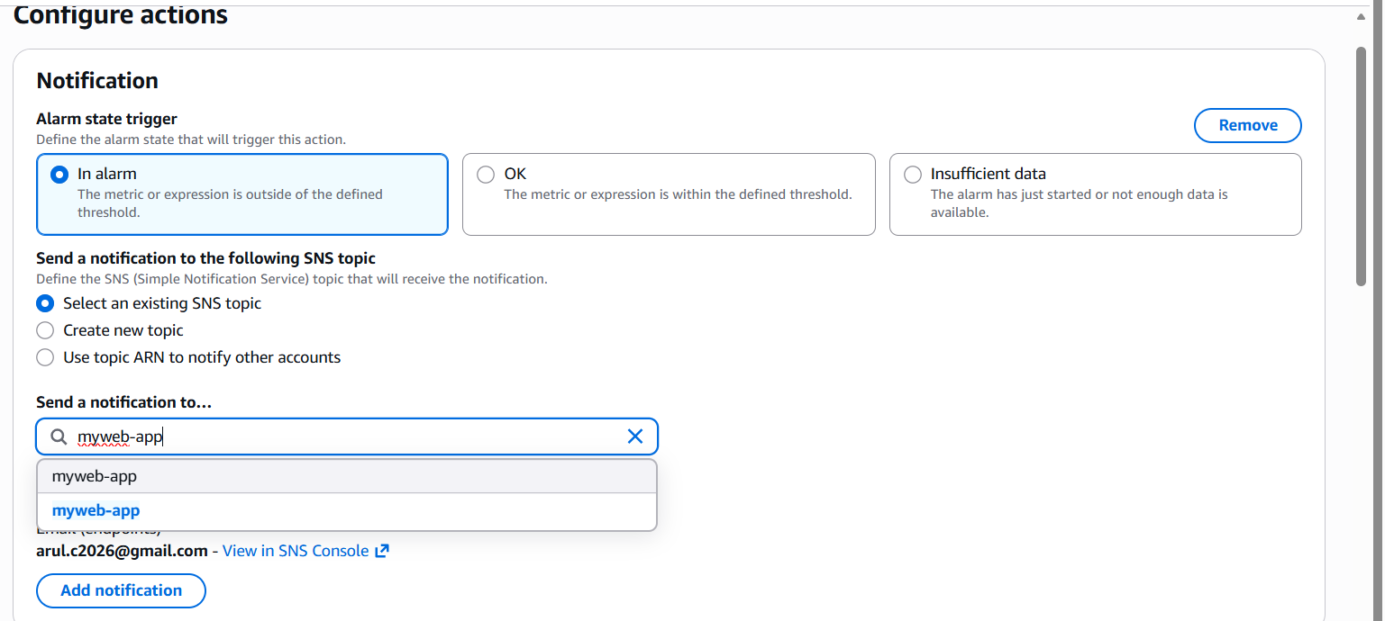
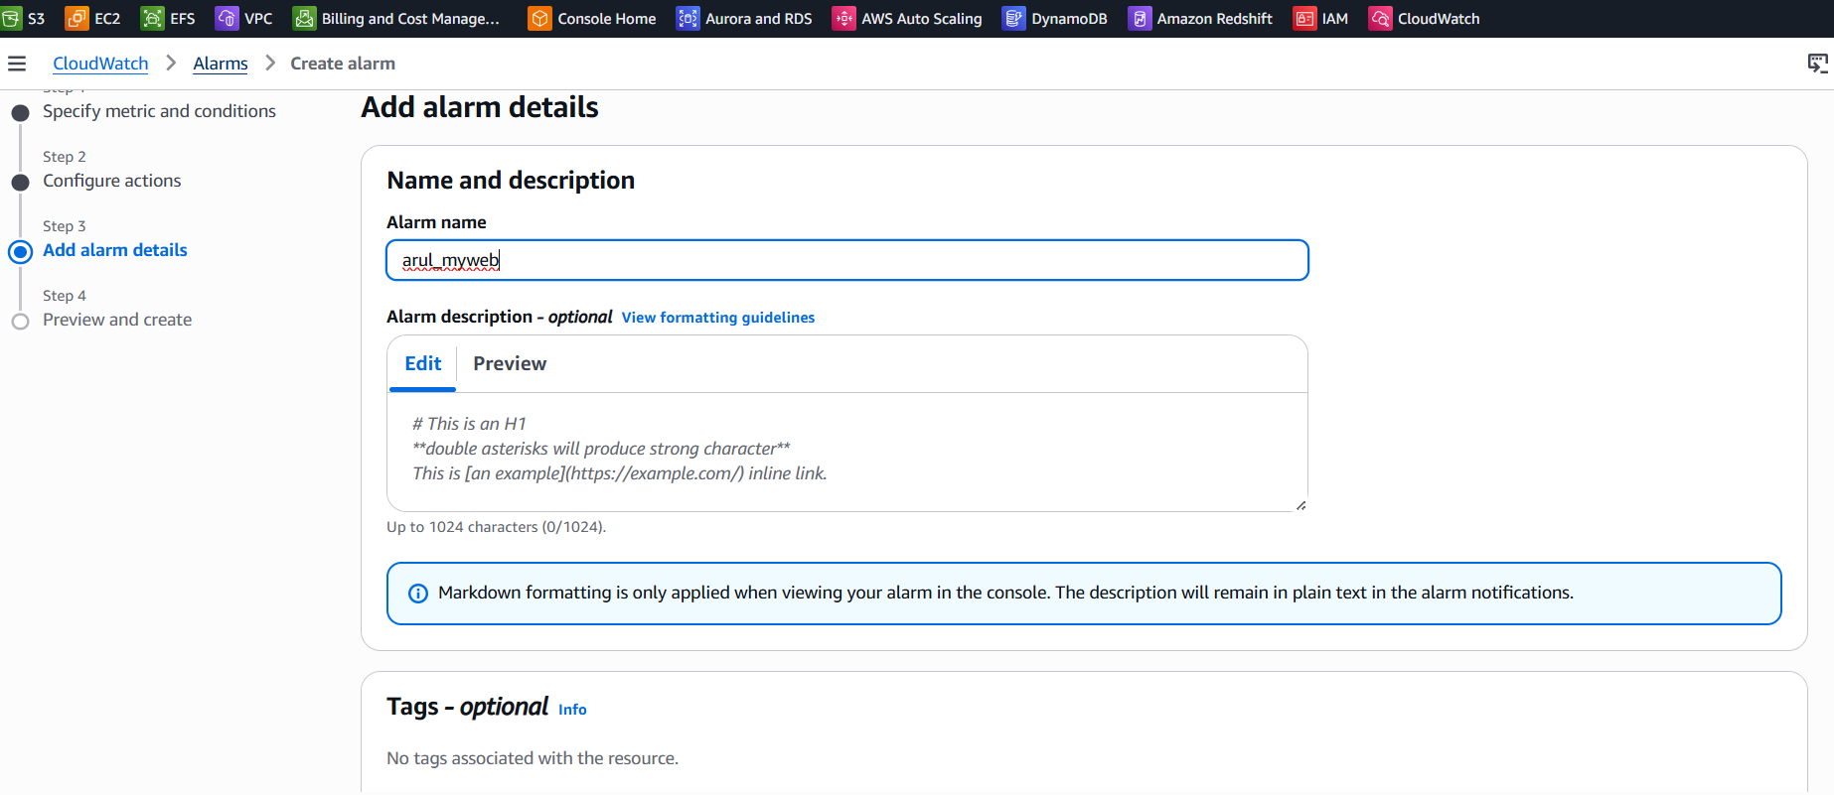
Installing the “stress” package and generate CPU load on both servers:
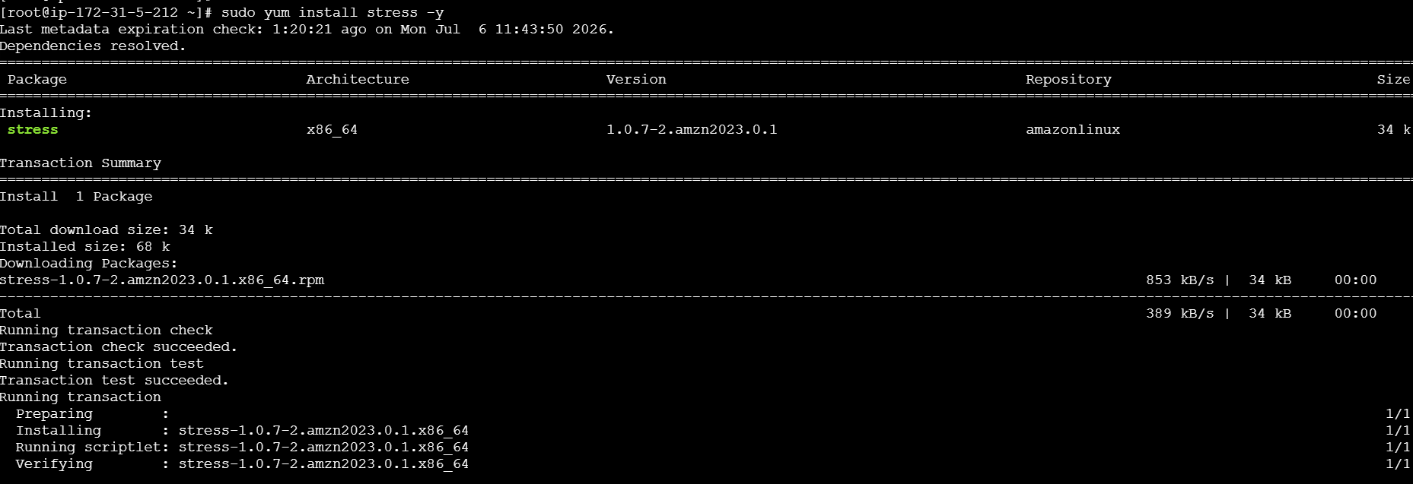
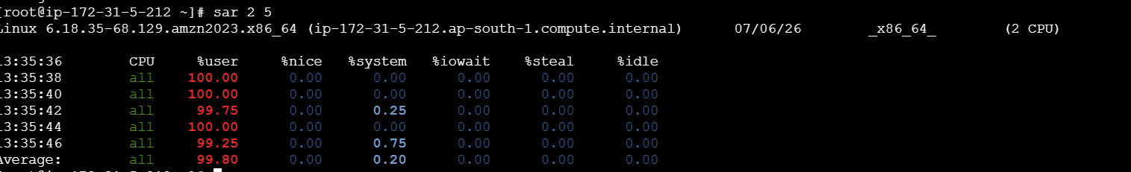
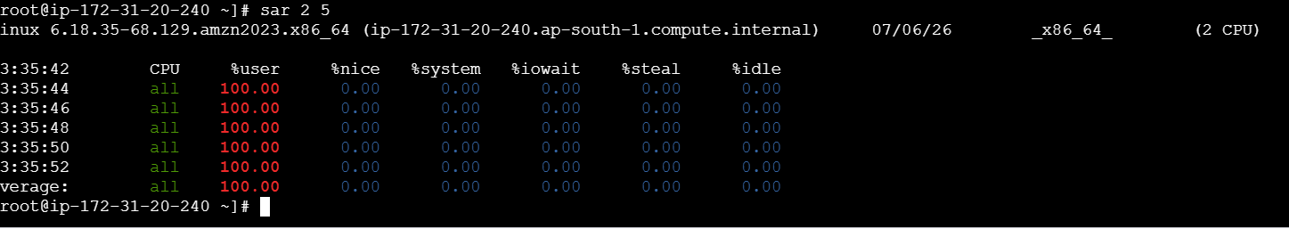
CPU load is high under cloud watch monitoring:
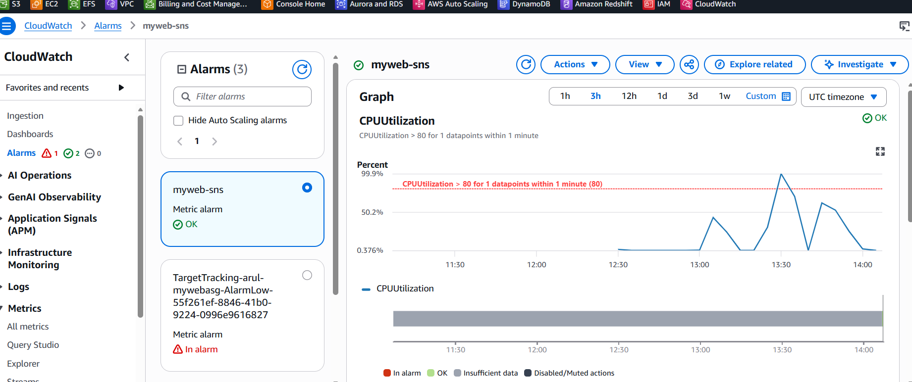
Watch under ASG activity log for auto scaling: Due to CPU load, 2 instances were newly provisioned.
i-01fb1ade42f097389 - 172.31.44.204
i-06b0b4f741de72192 - 172.31.10.139
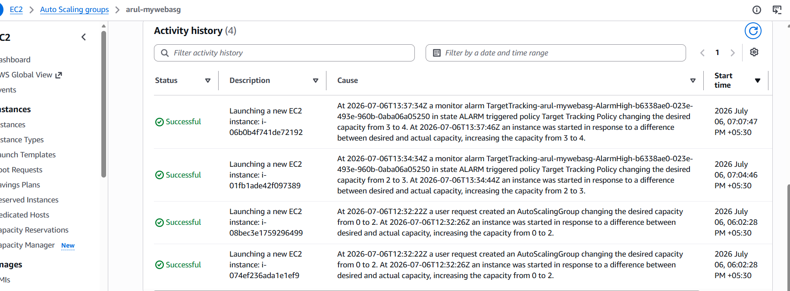
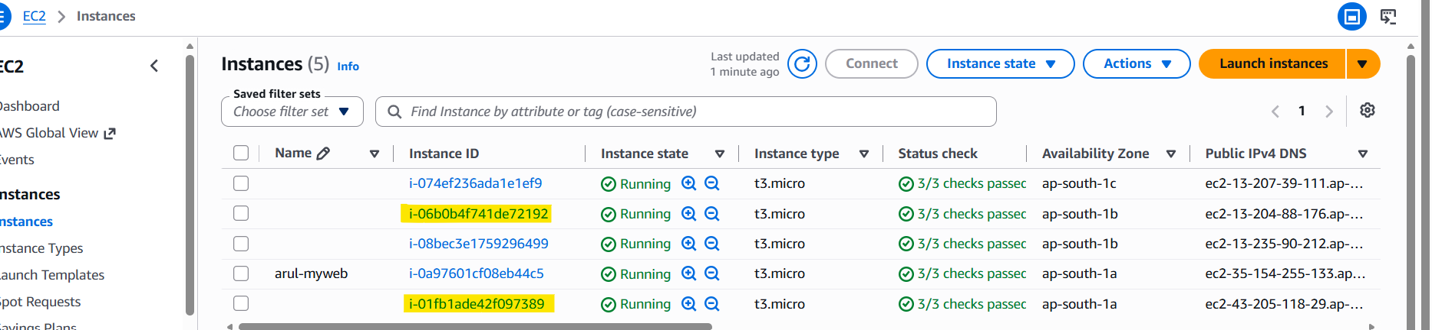
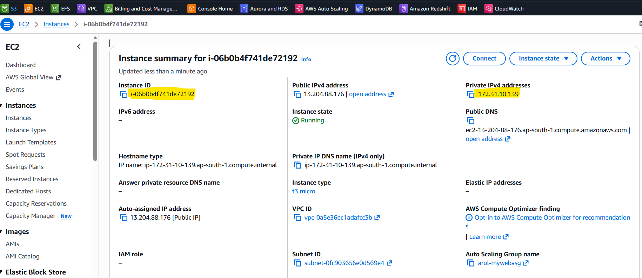
Load is distributed to new machines also:
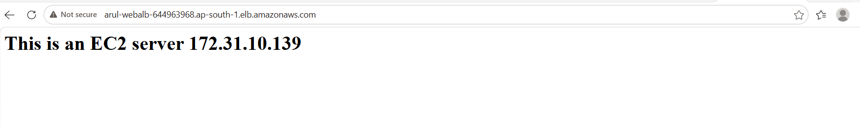
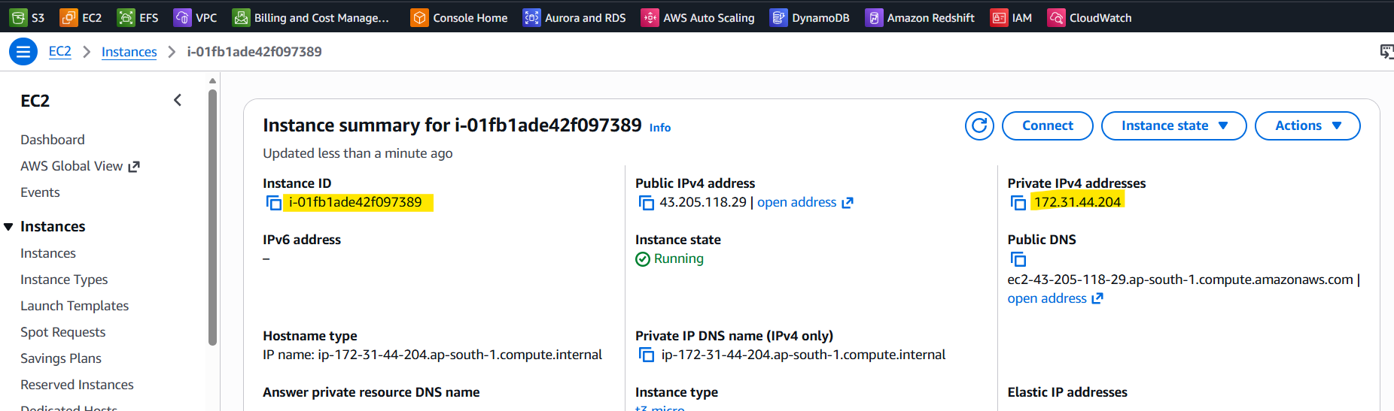


After CPU load reduced, 2 instances were terminated automatically:
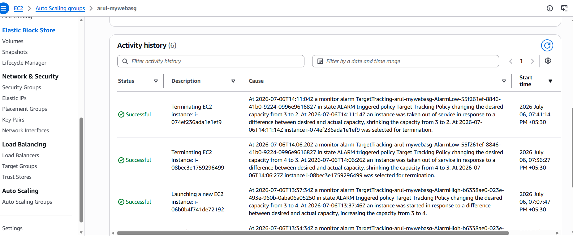
Method 2: Creating Step Scaling for auto scaling configuration
1.Create a Scale-Out Policy to add a resource: arul_upscaling
CPU usage > 80%
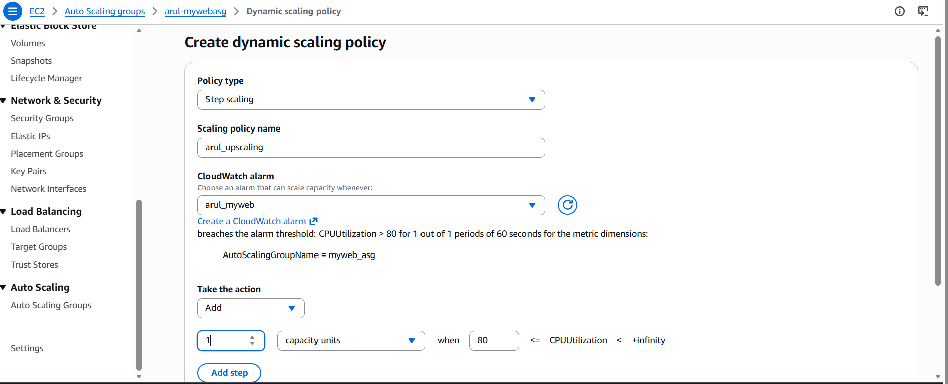
2.Create a Scale-in Policy to remove a resource: arul_downscaling
CPU usage < 60%
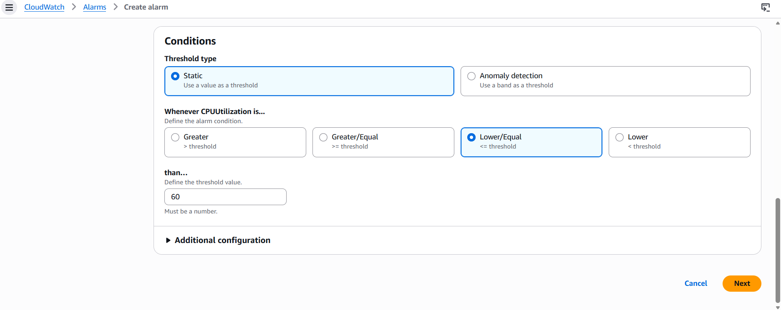
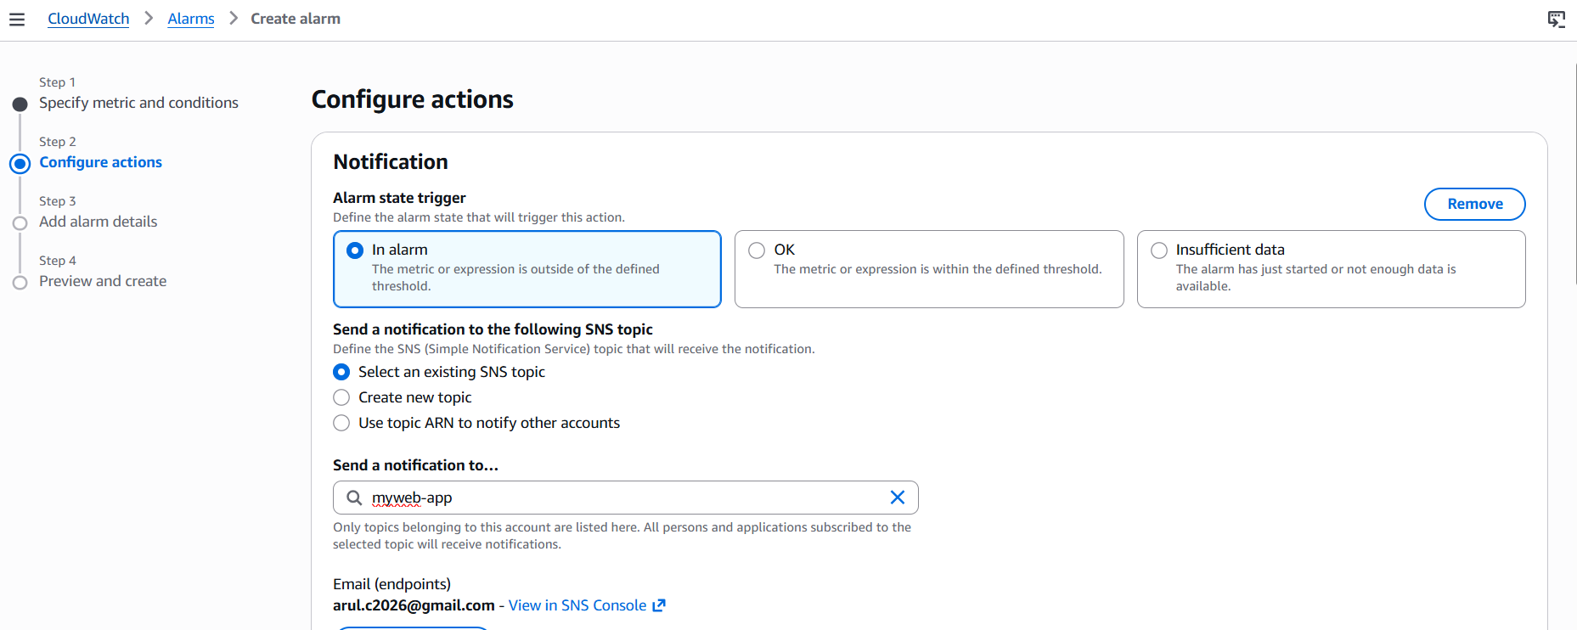
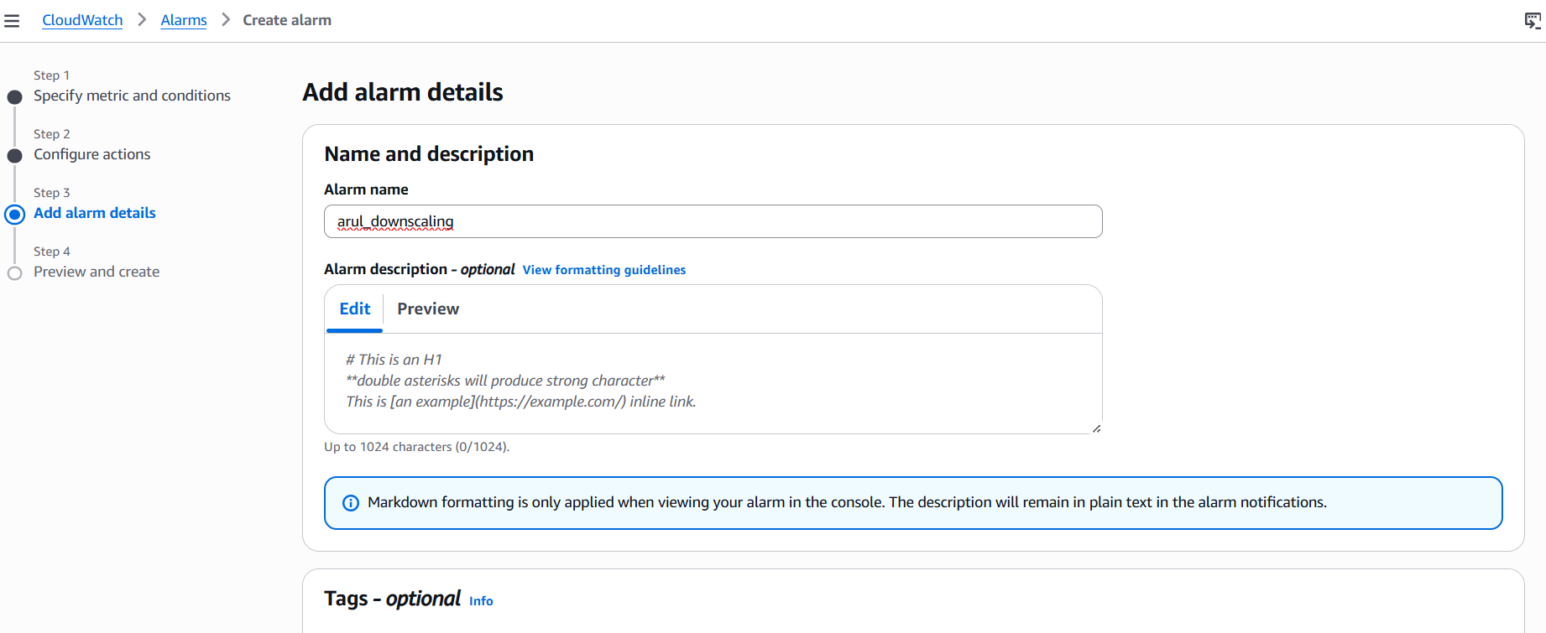
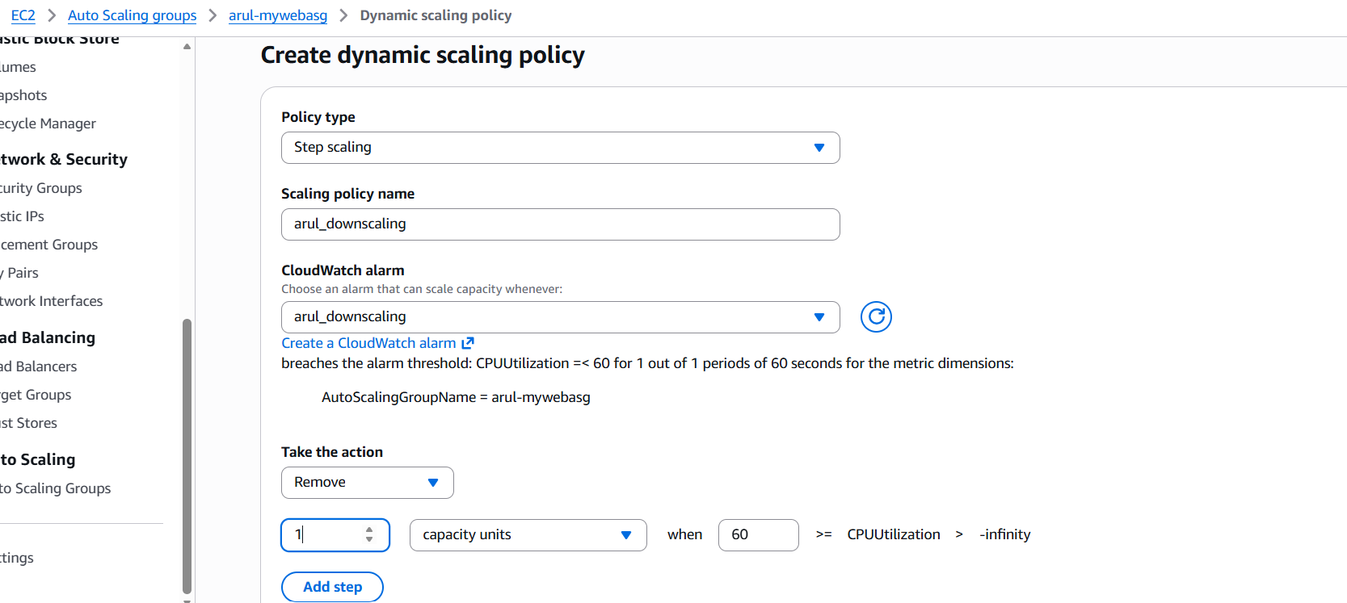
Both policies were created:
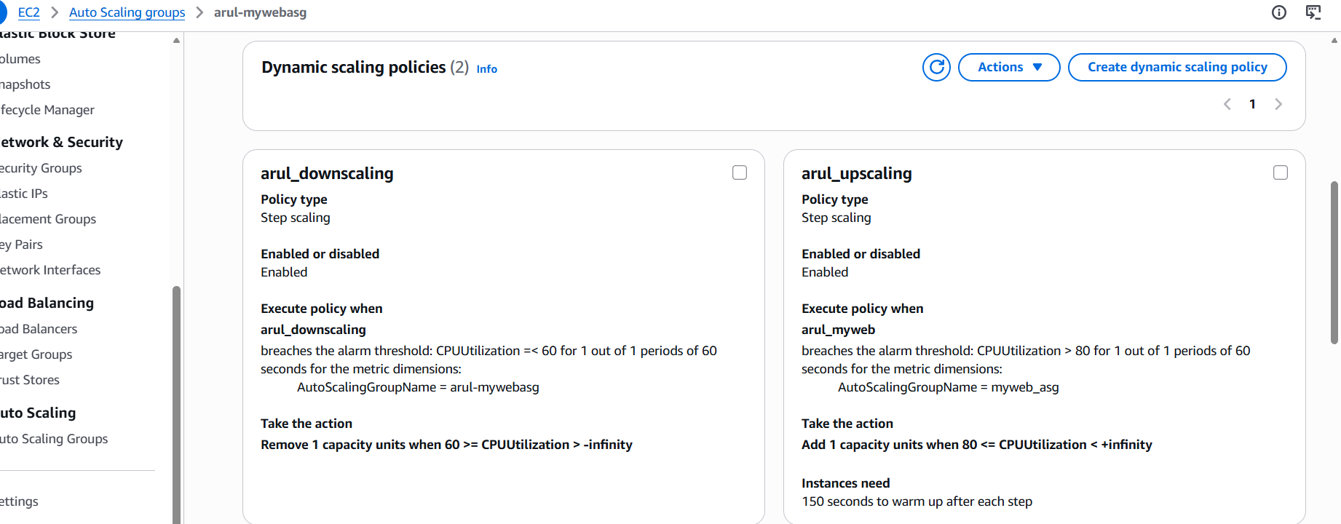
When CPU usage is high: New instance is created
Once Load is reduced, one instance is terminated
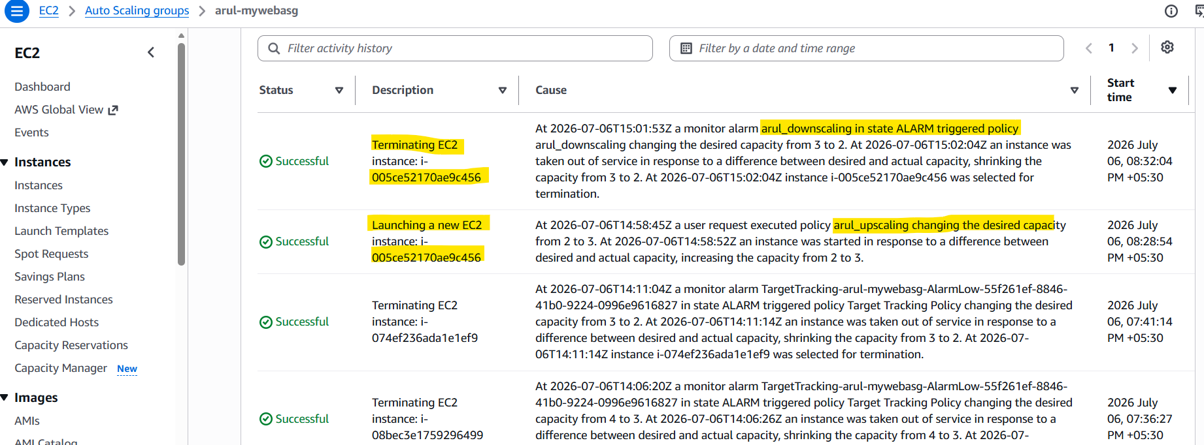
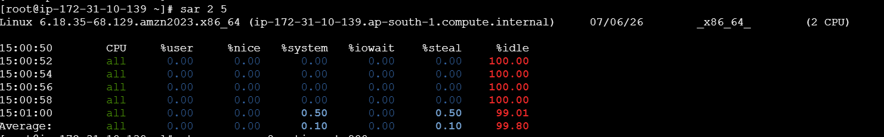
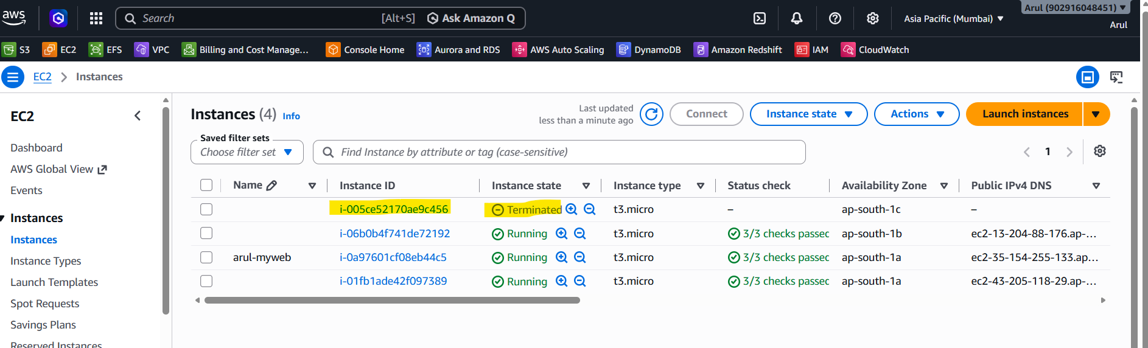

Route 53: As the domain registration takes money, unable to perform the last task.
